Draft for Comment
[DATE]
Publishing a “buildable” digital health blueprint for [Country]
Developing an implementable, conformance-testable, standards-based digital health infrastructure specification that operationalizes person-centric, guideline-adherent care at national scale.

Contents
Introduction 4
Document purpose and intended audience 4
Key takeaway messages 4
Layout of this document and its sections 4
Burden of Disease 6
Demographics 6
Health system operations 7
Burden of disease 7
Discussion regarding implications of the IHME indicators 7
Digital Health Readiness 8
GDHM Overview 9
Leadership & Governance 9
Strategy & Investment 9
Legislation, Policy, & Compliance 9
Workforce 9
Standards & Interoperability 9
Infrastructure 9
Services & Applications 10
Discussion and Implications of the GDHM indicators 10
National Health and Digital Health Strategies 11
Overview and background 11
Discussion related to the country’s strategic plans 11
Mapping strategic goals to HIE design specifications 12
Components of a “buildable” Health Information Exchange 13
Overview and background 13
Conformance-testable Building Blocks 20
Terminology Service (TS) 21
Client Registry (CR) 22
Facility Registry (ILR-FR) 24
Facility type codes 25
Health service type codes 26
Health Worker Registry (ILR-HWR) 27
Health worker type codes 28
Shared Health Record Repository (SHR) 28
Interoperability Layer (IL) 29
Health Management Information System (HMIS) 29
Implications for Cross-domain Integration 30
Point of Service application (POS) 32
Digital Health Landscape and Quick-win Opportunities 35
High-level overview of broadly deployed digital health solutions 36
Mapping existing solutions to HIE actors 36
Governing the National HIE 37
A conceptual policy framework for national scale health data sharing 37
Health Data Governance 37
Health Data Sharing 38
Exerting MOH governance over disparate digital health projects 40
Conclusion & Next Steps 43
Developing the Blueprint Artefacts 43
National Digital Health Blueprint 43
National Norms and Standards for Digital Health 43
Publication and Dissemination 44
Appendix 1: Example Use Case – Diabetes 45
Archetypal Transaction Patterns 45
TX-A: Establish HW credentials and care context 47
TX-B: Establish Unique Patient ID – TX-B 48
TX-C: Retrieve Patient IPS 49
TX-D: Guideline-based care delivery 50
TX-E: Post Encounter details and updated Patient IPS to HIE 53
Demonstrating CCG-based Diabetes Care 54
Appendix 2: 10-year HIE Investment Rationale 55
Assumptions 55
Demographics 55
Facilities 56
Economics 56
Theoretical DALYs 57
Investment Rationale Model (example) 57
Summary 57
Governance 58
Datacentre 59
CR (client registry) 60
ILR-FR (Interlinked Facility Registry) 61
ILR-HWR (Interlinked Health Worker Registry) 61
SHR (Shared Health Record repository) 61
TS (Terminology Service) 62
HMIS (Health Management Information System) 63
CUA (Cost Utility Analysis) 63
Results 63
Discussion 66

Introduction
This section describes the document’s purpose and intended audience, a summary of key takeaway messages, and the layout of the document including its sections and appendices.

Document purpose and intended audience
[This section should be two or three paragraphs long. This document will become the basis of the MOH’s Blueprint document. There should be a one-paragraph description of the MOH Blueprint’s eventual purpose and the ways this document will support that effort. For example, if the document is a companion to the national digital health strategy, cite the strategy (including date and version, if applicable) and describe how this document augments that one. Following the short description of purpose, the target audience should be identified. Generally – a document of this type will be employed by the MOH or by a relevant digital health agency to inform their national Blueprint artefact. That said – there may be other stakeholders who will make immediate use of the technical sections, especially the conformance-testable definitions. These other parties (such as software development teams, NGO partners, ministry-hosted conformance testing organizations, etc.) should also be named.]
<insert 2-3 paragraphs, here>

Key takeaway messages
Following are the document’s key takeaway messages.
[This section should list 5-10 key takeaway messages supported by the subsequent sections of the document. A useful format to consider is for each key message to have a one-sentence description (in bold font) followed by a one-paragraph narrative description which may include a graphic. The purpose of this section is to provide an executive summary that could be read by a senior decision-maker in less than 4 minutes, and which conveys enough information to support a go/no-go decision on the digital health infrastructure project.]
<insert 5-10 key messages, here>

Layout of this document and its sections
This document is prepared in six sections and two appendices:
[This section is a bulleted list of the blueprint’s chapters. Each chapter heading should be followed by a one-sentence description. As applicable, the following example text should be edited to reflect the present context.]
- Introduction: this section – which includes the purpose and intended audience, key takeaway messages, and the layout of the document.
- National Burden of Disease: a high-level summary and analysis of the key burdens of disease in <country> as reported by the Institute for Health Metrics and Evaluation (retrieved: <retrieval date>).
- National Digital Health Readiness: a summary of the country’s scoring across the key metrics of the Global Digital Health Monitor (GDHM) and the anticipated implications for the national infrastructure project.
- National Health and Digital Health Strategies: a summary overview of the elements of the national health strategy and the national digital health strategy that directly apply to shared infrastructure (the national Health Information Exchange, HIE) and a mapping of key strategic goals to operational workflows.
- Components of a Health Information Exchange: a description of architectural actors in a national HIE and the roles they play in operationalizing key workflows. This section articulates a conformance-testable set of national digital health norms and standards.
- Digital Health Landscape and Quick-win Opportunities: a high-level overview of existing solutions deployed at scale that can be quickly leveraged to give a “running start” towards a national infrastructure.
- Digital Health Governance: a recommended governance structure that may be leveraged to ensure coordination and resource pooling across the various disparate digital health activities. A suggested policy structure is also described that supports national scale health data exchange across both private and public sector care providers.
- Appendix-1: Example Use Case: this section provides a worked example of digitally enabled care workflows using <example condition> as the target. This example generically references WHO’s recommended care guidelines and maps these guideline-based care pathways to the blueprint’s architectural actors and the care delivery workflows they support.
- Appendix-2: Exemplar 10-year Digital Health Investment Plan: this section leverages a digital health investment tool to develop a 10-year cost-utility analysis (CUA). The model’s assumptions are documented, and a sensitivity analysis illustrates the impacts of key implementation-related variables on cost-effectiveness, as measured against the national Cost-effectiveness Threshold (CET).

Burden of Disease
Key points:
- Point One…
- Point Two…
- Point Three…
Key recommendations:
- Recommendation One
- Recommendation Two

[Begin each section with a summary box. This should be very brief. Resize the box to accommodate your summary points.]
This section summarizes the country health metrics reported by the Institute for Health Metrics and Evaluation (IHME). IHME is a global repository of health metrics and indicators. It develops and reports metrics based on the country content found at the Global Health Data Exchange. This section includes IHME’s reported country data on demographics, health system operations, and burden of disease.
The following content is from the most recent statistics published by IHME. IHME’s graphics are included in this document without alteration.
[The following sections cite content from IHME. IHME is treated by World Bank, WHO and others as a trusted source of burden of disease information. As such, it is recommended that the IHME content should appear in the blueprint report, unmodified. TWG members’ inputs and observations related to the IHME data should be faithfully reflected in the Discussion section at the end of the chapter.
The content for the following sections is found at https://www.healthdata.org/. Use the Search function to find the country profile for the subject country. For example, the profile for Amalgaland would be found at https://www.healthdata.org/amalgaland.
NOTE: the purpose of this section of the blueprint is to ground the document in the present realities of the country’s health and demographic context. Information here will provide the supporting data for the investment rationalea.]

Demographics
[The demographics data, itself, may be a few years out of date (e.g. for population) so the most up-to-date sources should always be cited. However, the forecast for future population and future population pyramid from IHME should be included, here. Because they are easy to immediately understand, it is suggested to embed the appropriate corresponding graphics for the subject country directly in these sections.]

Health system operations
[In this section, include IHME information (and maybe graphics) related to expenditures and UHC effective coverage.]

Burden of disease
[The causes of death and causes of death and disability combined (burden of disease) are crucial to informing the use cases and the “investment rationale” of the digital health investment plan. The risk factors help identify where digital health can be impactful on this burden. IHME’s information and graphics related to these should be included here.]

Discussion regarding implications of the IHME indicators
[TWG members’ inputs and observations related to the IHME data should be faithfully reflected in this section. Based on the facilitator’s research, other notes may be called out here, too. These could include, for example, observations related to shifting burden of disease (from infectious to NCD, as an example), or related to life expectancy, or related to forecasts for total health expenditure or of the proportion of out-of-pocket spending vs. government-funded health spending.
It is worthwhile, in this section, to make particular note of trends or data that will impact the investment rationale. This includes drawing attention to risk factors that are amenable (or are not amenable) to being impacted by digital health interventions.
Because of how important it is later in the investment rationale, it is recommended to prepare a table listing the top-10 DALYs’ causes, and the total disability-adjusted life-years for each. Such content may be obtained from IHME’s GHDx site: https://vizhub.healthdata.org/gbd-results/.
It is anticipated that this section will be 1-2 pages long.]

Digital Health Readiness
Key points:
- Point One…
- Point Two…
- Point Three…
Key recommendations:
- Recommendation One
- Recommendation Two

[Begin each section with a summary box. This should be very brief. Resize the box to accommodate your summary points.]
This section summarizes the country’s readiness scores across the different axes of the Global Digital Health Monitor. An overall digital health readiness score is reported as well as individual metrics related to:
- Leadership & Governance
- Strategy & Investment
- Legislation, Policy, & Compliance
- Workforce
- Standards & Interoperability
- Infrastructure
- Services & Applications.
As noted on their website, “[t]he Global Digital Health Monitor (GDHM) is an interactive web-based resource that aims to track, monitor, and assess the enabling environment for digital health throughout the world.”
The following content is from the most recent survey results from the GDHM site augmented by insights from the relevant TWG workshops.
[The following sections cite content from GDHM. GDHM is treated by World Bank, WHO and others as a trusted source of digital health readiness assessment. As such, it is recommended that the GDHM content should appear in the blueprint report, unmodified. TWG members’ inputs and observations related to the GDHM data should be faithfully reflected in the Discussion section at the end of the chapter.
NOTE: if there is no GDHM content for the country, or if the content is woefully out of date, then the GDHM Google Form survey responses may be employed in this section – with a clear notation that these “TWG” data are being reported.
The purpose of this section of the blueprint is to further ground the document in the le realities of the country’s context. Information here will provide supporting data for the investment rationale and, importantly, the level of effort and time needed to roll out a national implementation.]

GDHM Overview
[On the GDHM country website page, select an appropriate regional comparator. As an example, for a sub-Saharan country, choose “Africa Region” in the “Compare to” drop-down box. Capture (copy) the “spider graph” that illustrates the GDHM score and the comparator score for each metric. It is also recommended to capture the Context, Health, and Country Summary information and to faithfully include it in this section. Note the country’s overall score.
NOTE: if the GDHM Google Form was employed, leverage the Toolkit’s GDHM spider graph spreadsheet to create the necessary graphic and include the graphic, only, in this section.]

Leadership & Governance
[Capture (copy) content from the relevant GDHM section and paste it here. Provide a short narrative comment regarding what are the likely implications of the reported phase-level.]

Strategy & Investment
[Capture (copy) content from the relevant GDHM section and paste it here. Provide a short narrative comment regarding what are the likely implications of the reported phase-level.]

Legislation, Policy, & Compliance
[Capture (copy) content from the relevant GDHM section and paste it here. Provide a short narrative comment regarding what are the likely implications of the reported phase-level.]

Workforce
[Capture (copy) content from the relevant GDHM section and paste it here. Provide a short narrative comment regarding what are the likely implications of the reported phase-level.]

Standards & Interoperability
[Capture (copy) content from the relevant GDHM section and paste it here. Provide a short narrative comment regarding what are the likely implications of the reported phase-level.]

Infrastructure
[Capture (copy) content from the relevant GDHM section and paste it here. Provide a short narrative comment regarding what are the likely implications of the reported phase-level.]

Services & Applications
[Capture (copy) content from the relevant GDHM section and paste it here. Provide a short narrative comment regarding what are the likely implications of the reported phase-level.]

Discussion and Implications of the GDHM indicators
[Here is the place to draw an overarching summarization of the country’s digital health readiness. Provide narrative comments and relevant TWG inputs that speak to the likely implications of the reported phase-level. Address questions like: where will we need to make extra investments (e.g. governance? infrastructure? etc.) what will be the implications on our pace of deployment? (we can go fast… we will be limited to the pace of mobile phone adoption, etc.)]

National Health and Digital Health Strategies
Key points:
- Point One…
- Point Two…
- Point Three…
Key recommendations:
- Recommendation One
- Recommendation Two

This section summarizes the country’s current health and digital health strategies and documents their alignment to the burden of disease, and to each other.
[The following sections cite content from the country’s health strategy (most recent version) and digital health strategy (most recent version). If these documents are not current enough to be relevant to the present blueprint, then consensus information collected during the facilitated workshops will be cited, instead, in the blueprint document.]

Overview and background
[This section should faithfully document details that were used as inputs to the TWG workshops. The publication date or version of each document should be noted. Overview narrative from the Executive Summary sections of the health strategy and digital health strategy should be cited, here – including relevant graphics that give a big-picture view of each strategy and its key focus areas.
The summary information should include elements such as: (1) key target care delivery programmes identified and health improvement targets (where applicable); (2) care network design changes, if applicable, such as consolidation of or devolving of funding and/or responsibilities; (3) relevant data reporting requirements; (4) UHC-focused initiatives and their target timelines; (5) health enterprise architecture choices, if relevant (e.g. has OpenHIE been adopted… has FHIR been adopted… etc.); (6) key digital health product choices that have been made (e.g. DHIS2… HAPI FHIR… etc.).
Where relevant, it may be useful to frame elements of the strategy in terms of the WHO-ITU National eHealth Strategy Toolkit (2012).
This “Overview and background” section should not exceed 4-5 pages.]
<Insert “Overview and background” text here>

Discussion related to the country’s strategic plans
[This section should reflect discussion that arose from the facilitated TWG workshop related to the country’s strategic plans. The section should include graphics depicting results from workshop’s the real-time questionnaires. Particular note should be made of areas where there are mismatches or misalignments between the health and digital health strategies or where either (or both) appear to be misaligned to the country’s present burden of disease.
In cases where either strategy document may be considered out of date – this section can be leveraged to document TWG consensus on what present context should drive the content of the buildable blueprint. If there has not yet been an opportunity to refresh the strategies to reflect impacts of the pandemic, this section can also be employed to document new realities that should be addressed by the blueprint.
This discussion section should not exceed 2-3 pages.]
<Insert “discussion related to strategic plans” text here>

Mapping strategic goals to HIE design specifications
[This section should call out specific areas of the strategic plans that will rely on the successful deployment, at scale, of elements of the buildable blueprint. The narrative in this section serves as an introduction to the technical design elements in the following section and gives an overview of their “role” in satisfying the “business needs” articulated by the strategies.
The narrative in this section could call out strategic elements, for example, related to offering insured services to citizens – and map these to the need for a demographic database (a client registry) and the unique IDs (e.g. health cards) that may be needed to operationalize insured, person-centred care. Likewise, goals related to improved disease surveillance could be mapped to data content models and coding schemes that will be needed in order for reportable health events to be collected into meaningful statistics. These are just examples; the map will depend upon what is in the relevant country strategies.
This mapping section should not exceed 1-2 pages.]
<Insert mapping narrative, here>

Components of a “buildable” Health Information Exchange
Key points:
- Point One…
- Point Two…
- Point Three…
Key recommendations:
- Recommendation One
- Recommendation Two

This section describes the building blocks of a national health enterprise architecture and how these building blocks may be leveraged to construct a working health information exchange (HIE).
[This section describes the elements of an OpenHIE-on-FHIR based health enterprise architecture. The transaction-processing behaviours of each architectural “actor” are defined in terms of conformance-testable IHE Profiles. The person-centric health data model is based on the FHIR-based International Patient Summary (IPS) implementation guide (IG).
It is the intent of this “buildable blueprint” to leverage existing, widely adopted, conformance-testable norms and standards. These standards (and the OpenHIE architecture) are supported by WHO as the foundation of its digital health strategy. The assumption, therefore, for this toolkit is that the TWG will adopt existing specifications to the fullest extent possible; it will adapt these specifications where necessary; and only as a last resort will net-new specifications need to be developed from scratch.]

Overview and background
[This section provides a technical description of the OpenHIE-on-FHIR actors and the transactions each actor executes in service of a national HIE. Each HIE building block is described at a top level and the way they fit together is illustrated. The design depicted in this section assumes a cloud hosted infrastructure that operationalizes high-performing FHIR Services.]
Figure 13 - OpenHIE Blueprint (health-related actors)
The buildable blueprint design leverages an existing, “off the shelf”, set of digital health architectural specifications as generally defined in the OpenHIE framework. The OpenHIE Architecture diagram is shown in Figure 13. To bring the blueprint to life, its care delivery workflows are mapped to a set of implementable, standards-based, interoperability specifications as defined by the IHE Mobile Health Document Sharing (MHDS) Profile. A set of architectural “actors” relevant to an OpenHIE-conformant HIE are listed in Table 1. An engineering diagram depicting how an OpenHIE-based architecture could be operationalized in a cloud-hosted infrastructure is illustrated in Figure 14.
- TS*: a terminology server that supports ontology mapping and code list publishing  - CR*: a standalone client registry that supports patient record matching and de-duplication  - CR* POS: a client application that supports the “ceremony” of adding a new demographic record to the HIE (e.g. ID card printing, etc.)  - POS Solution: point of service digital health application (e.g. Electronic Medical Records (EMR), Lab Information System (LIS), Community Health Worker app, etc.)  - CCG Engine: computable care guidelines processor  - Interoperability Layer: enterprise shared service bus | - CR: runtime client registry service  - ILR/TS: runtime terminology service, including interlinked health service codes  - ILR-HWR: runtime interlinked health worker registry  - ILR-FR: runtime interlinked facility registry  - ILR-ORG: runtime interlinked organization registry  - SHR: shared health record repository  - HMIS: health management information system, including a data analytics engine  - HWD: federation of health worker directories  - FD: federation of facility directories  - ORG: federation of organization directories  - ATNA: audit trail and node authentication services
Table 1 - Digital health infrastructure actors
Figure 14 – Functional Capability of a Cloud-hosted OpenHIE-based architecture
As may be noted from the diagram, it is anticipated that the national HIE will be cloud hosted. To defend online transaction processing (OLTP) performance, computationally “expensive” services such as terminology mapping and publishing, client record creation and management (e.g. de-duplication), and analytic processing (e.g. HMIS) will be architecturally separated from the OLTP-optimized FHIR Services. It is also expected that the interlinked registry (ILR) of health workers, facilities, organizations, and health services will be refreshed from an underlying federation of directories as part of a regular maintenance cycle. As an example, extracts from the membership databases of the College of Nurses, College of Physicians, College of Pharmacists, etc. will be regularly updated to the OLTP FHIR Server’s interlinked registries as part of a managed batch update process.
The following list outlines the HIE’s transactional functionality as depicted in Figure 14. Transactions supporting maintenance processes are identified in blue; real-time processes are shown as yellow.
- Terminology Publishing. A terminology server (TS*) will be employed to curate and cross reference the national lists of normative codes. As part of a regular refresh process, the MOH will publish updated code lists and make these available so that digital health POS solutions can update their code lists. This is illustrated by transaction (1). As shown by transaction (2), these published terminologies will also update the runtime code lists maintained in the OLTP-optimized FHIR Server. NOTE: it is common for such publishing processes to employ Excel and/or PDF files as the means of distributing code lists. Each POS solution will be required to be able to ingest the published format. The interactions with the TS* may be managed via the Interoperability Layer.
- Manage Client Registry Records. It is expected that there may be a ceremony associated with managing Client Registry records. A barcoded unique ID card may be issued, as an example, that will associate the client’s demographic information with their unique health identifier. As part of maintenance, duplicate client records that have been created in error will need to be de-duplicated (and the underlying IDs merged). These processes may be operationalized by every POS, or there may be a specialized solution (CR* POS) that is dedicated to efficiently and correctly executing client record ID-management, including the “new client ID” ceremony. The CR* POS will need to support both adding and updating client demographic records, as illustrated by real-time transactions (3) and (4). The CR* server will need to be able to sync new or updated client demographic records to the HIE’s OLTP-optimized FHIR Server, as shown in transaction (5). If there is a separate CR* POS, and if an offline mode must be supported, there may be a sync transaction between a POS Solution and the dedicated CR* POS application. This is shown as transaction (6). NOTE: the CR* POS’ interactions with the CR* may be managed via the Interoperability Layer.
- Query for a Client Demographic Record. As part of its normative behaviour, a digital health POS will need to be able to query the HIE for a client demographic record. The HIE’s FHIR Server, playing the role of a Client Registry, will need to be able to respond with the relevant record(s). This is shown as transaction (7).
- Query for a Client’s Patient Summary. As part of its normative behaviour, at the beginning of an encounter, a digital health POS will need to be able to query for and ingest/parse a client’s (IPS) patient summary document. The HIE’s FHIR Server, playing the role of a Shared Health Record repository, will need to be able to respond to a POS request by returning a well-formed IPS. This is shown as transaction (8).
- Submit a Client’s Patient Summary. As part of its normative behaviour, at the end of an encounter, a POS must be able to submit a well-formed IPS to the HIE that includes the details of the encounter including any forward-looking orders or follow-up. The HIE’s FHIR Server, playing the role of a Shared Health Record repository, must ingest/parse the inbound IPS and persist it. This is shown as transaction (9).
- Execute Computable Care Guideline (CCG) Processing. Transaction (9) is also employed, during an encounter, to launch the processing of one or more CCGs. A POS solution provides a CCG Engine actor with the client’s current IPS using transaction (9) and invokes a $apply operation using transaction (17). Relevant guideline-based care recommendations are returned from the CCG Engine actor and processed by the POS solution. Actions that operationalize the CCG-based recommendations (e.g. measure and record blood pressure, order medications, etc.) are reflected in the client’s real-time IPS. Over the course of the encounter, the transaction 9-17 pattern is repeated until no further recommendations are returned from the CCG Engine.
- Query for Interlinked Registry Content. As part of routine processes, a POS may need to query the HIE for information related to facilities, organizations, health workers, available services, and/or the relationships between these. The HIE’s FHIR Server, playing the role of an Interlinked Registry (ILR), will respond to the query and return the relevant content. Such a query against the interlinked registry is shown as transaction (10).
- Query for Codes. As part of routine processes, a POS may need to lookup a code, validate a code, query for a concept map, or query for a translation from one code system to another. The HIE’s FHIR Server will need to be able to respond to such requests. These are shown as transaction (11), (12), (13) and (14), respectively.
- Submit Reportable Indicators. There may be MOH mandates for POS solutions to regularly submit reportable indicators (e.g. number of new HIV patients started on antiretroviral medications, number of babies receiving their DPT-3 immunization, etc.). Such a submission, shown as transaction (15), will be directed to the HIE’s Health Management Information System (HMIS). As an alternative, an MOH could opt to leverage a “t-connector” in its data processing pipeline that could de-identify inbound patient summary submissions as part of a separate workflow that does not impede the transaction processing of the HIE’s OLTP-optimized FHIR Server. These de-identified, person-centric data could be persisted to the HMIS to support advanced analyses not possible with aggregated data, alone. Such a pipeline, which could operate either in near real time or as a batch, is shown as transaction (9*).
- Refresh and Update Interlinked Registries. The HIE FHIR Server’s data regarding facilities, organizations, and health workers will need to be regularly refreshed and the cross-referencing between these data will need to be governed and managed. The sources of these data are expected to be a federation of underlying health worker directories (HWD), facility directories (FD) and organization (ORG) directories. Some HMIS solutions, such as DHIS2 as an example, can also play the role of a facility directory or an organization directory. The refresh transaction is shown as transaction (16).
- Privacy, Security, and Auditing. The Interoperability Layer is used to manage the HIE’s transactional traffic. This includes enforcing key mandates related to authentication, authorization, privacy / consent, consistent time, and auditing. These are pervasive requirements that apply to all traffic that traverses the HIE.
To be good “HIE citizens”, POS solutions will need to follow a set of normative behaviours. These behaviours are described, using the business process modelling notation (BPMN), in Figure 15. This generic and re-usable care encounter pattern may be leveraged to support care delivery use cases across a wide range of healthcare scenarios. The care encounter pattern is mapped to the transactions (as described in Figure 14). The conformance testable IHE Profile transactions are also indicated (in red).
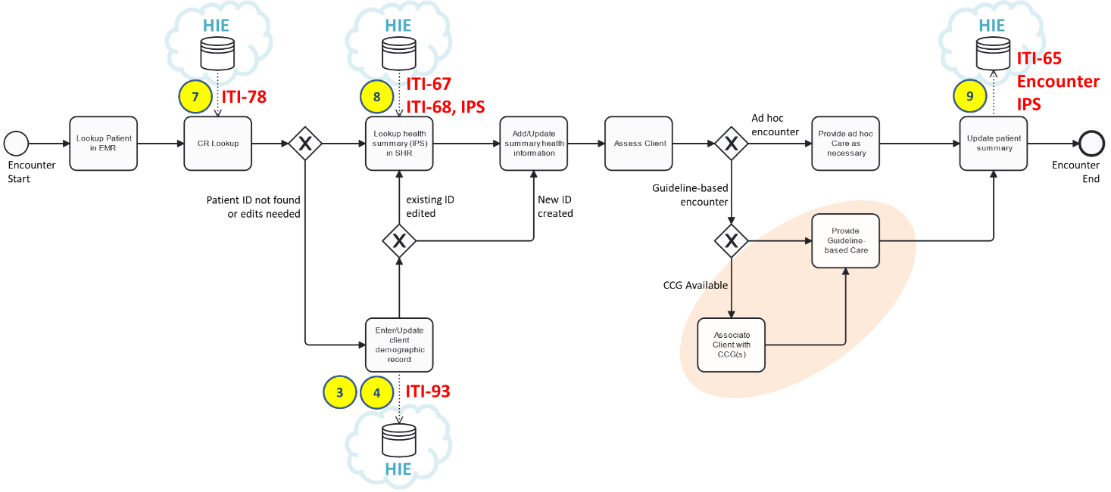
Figure 15 - Generic care encounter pattern
Following the flow of the diagram:
- A person-centric care encounter starts.
- The client’s patient demographic record is looked up in the local electronic medical records (EMR) database.
- The client’s “enterprise” demographic record is looked up in the HIE’s client registry (CR); this is transaction (7) and maps to IHE conformance testable transaction ITI-78.
- If the record is not found in the CR, or if the CR’s record needs to be updated with new information, new content is captured using the CR* POS transactions (3) or (4) and this is saved to the HIE’s CR using IHE transaction ITI-93.
- If the client’s record was found in the CR, the patient summary (IPS) is retrieved from the HIE’s shared health record (SHR) repository. This is transaction (8) in Figure 14 and leverages IHE transactions ITI-67 and ITI-68 and the IPS data specification.
- The client’s IPS is updated with relevant information. In cases where no previous client record existed, the patient summary is created as a brand-new record.
- The client is assessed.
- If it is an ad hoc encounter and guidelines do not apply, care is provided as necessary.
- If one or more care guidelines are applicable, guideline-based care is provided. In cases where relevant CCGs are available, the POS solution may transact with a CCG Engine leveraging transactions 9-17 in a repeating pattern. This latter scenario would occur in the orange-shaded area of Figure 15.
- The patient summary is updated to reflect the activities of the encounter. The encounter details (e.g. client ID, health worker ID, facility ID, timestamp, etc.) plus the client’s updated health summary are persisted to the HIE’s SHR. This is transaction (9) and uses IHE transaction ITI-65 along with the FHIR Encounter and IPS data models.
It is expected that POS solutions will maintain their own (local) copies of health data and that the HIE will be leveraged to share data between and across POS solutions. As a best practice, the originators of new data (e.g. blood pressure reading, lab order, etc.) should be the ones to assign the unique FHIR resource ID and this resource.id should be a standards-based globally unique ID (GUID). As a corollary to this best practice – when a POS solution retrieves content from the HIE, the resource IDs of the retrieved content should be faithfully persisted to the POS’ local database. Adopting this engineering discipline across the care delivery network will allow data management and de-duplication processes to successfully execute at all points of care.
To support high quality, patient-safe, continuity of care – a re-usable data model is leveraged to exchange patient-centric health information within the care delivery network. Following the “off the shelf” risk-mitigation and cost-reduction strategy, the blueprint design leverages the standards-based, conformance-testable data model defined in the International Patient Summary (IPS) specification.
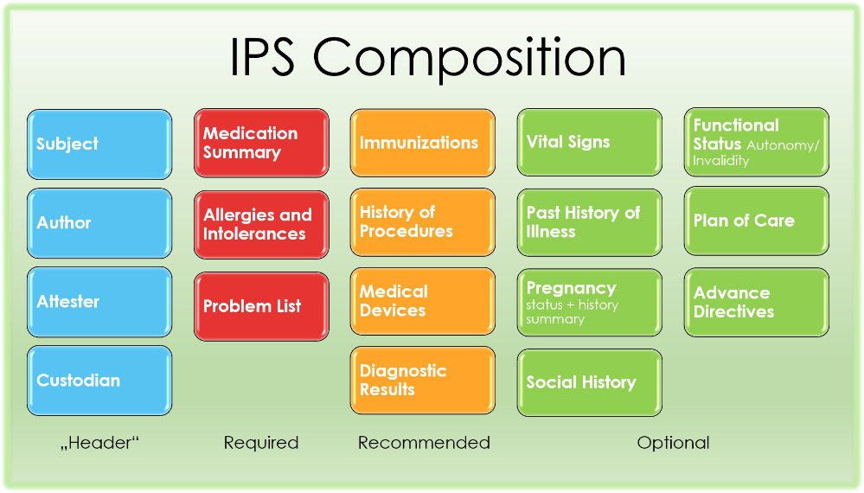
Figure 16 - IPS Data Model
The component data elements of an IPS “document” are listed below along with links to the underlying FHIR data model specifications (those noted with an (R) are mandatory; all others are “required if known”):
- Medication Summary (R) [ Medication Statement (IPS) | Medication Request (IPS) | Medication (IPS) ]
- Allergies and Intolerances (R) [ Allergy Intolerance (IPS) ]
- Problem List (R) [ Condition (IPS) ]
- Immunizations (S) [ Immunization (IPS) ]
- History of Procedures (S) [ Procedure (IPS) | Organization (IPS) | Device (performer, observer) ]
- Medical Devices (S) [ Device Use Statement (IPS) | Device (IPS) ]
- Diagnostic Results (S) [ Observation (Results) | DiagnosticReport (IPS) | Organization (IPS) ]
  - Laboratory results [ Observation (Results: laboratory) | Specimen (IPS) | Media observation (Results: laboratory, media) ]
  - Radiology results [ Observation (Results: radiology) | Device (performer, observer) | Imaging Study (IPS) | Practitioner (IPS) ]
  - Pathology results [ Observation (Results: pathology) | Specimen (IPS) | Media observation (Results: laboratory, media) ]
- Vital Signs [ Vital Signs ]
- Past history of illnesses [ Condition (IPS) ]
- Pregnancy (status and history summary) [ Observation (Pregnancy: EDD) | Observation (Pregnancy: outcome) | Observation (Pregnancy: status) ]
- Social History [ Observation (SH: alcohol use) | Observation (SH: tobacco use) ]
- Functional Status (Autonomy / Invalidity) [ Condition (IPS) | Clinical Impression ]
- Plan of care [ Care Plan ]
- Advance Directives [ Consent ]

To ensure semantic interoperability, different data elements in the IPS are required to be coded. The normative code systems specified for the IPS are:
- SNOMED International Patient Summary (IPS)
- WHO Anatomical Therapeutic Chemical (ATC) classification system
- LOINC
The IPS has undergone high level evaluation regarding its applicability against key care use cases. It is apparent that the IPS data model, unmodified, supports guideline-adherent care workflows related to immunization, antenatal care (ANC), diabetes, HIV, TB, and malaria. It is anticipated that all the key care workflows needed to address the country’s top-10 burden of disease would be supported without requiring extension or modification of the data model.

Conformance-testable Building Blocks
NOTE: The following sections contain normative content intended for a technical audience. The balance of the technical specification is laid out in eight main sections:
- Terminology Service (TS*/TS)
- Client Registry (CR*/CR)
- Facility Registry (ILR-FR)
- Health Worker Registry (ILR-HWR)
- Shared Health Record repository (SHR)
- Interoperability Layer
- Health Management Information System (HMIS)
- Point of Service Application (POS)
As a tactical matter, the underlying digital health standards are based on HL7 FHIR R4 and the IHE Profiles that operationalize these. The specific IHE Profiles are:
- International Patient Summary (IPS) – which is a data content standard that also references underlying code system specifications:
  - SNOMED International Patient Summary (IPS)
  - WHO Anatomical Therapeutic Chemical (ATC) classification system
  - LOINC
- Mobile Health Document Sharing (MHDS) – which is an umbrella specification that encapsulates underlying IHE Profiles:
  - Patient Master Identity Registry (PMIR)
  - Mobile Care Services Discovery (mCSD)
  - Mobile access to Health Documents (MHD)
  - Sharing Value Sets, Codes and Maps (SVCM)
  - Internet User Authorization (IUA)
  - Audit Trail and Node Authentication (ATNA)
  - Consistent Time (CT)
  - Aggregate Data Exchange (ADX) and Mobile Aggregate Data Exchange (mADX)
This strategy of referencing “off the shelf” specifications leverages the conformance tests that IHE has already defined for each of the Profiles named above.
The full text of the IHE Profiles, and their associated conformance tests (defined using IHE’s open-source testing platform: Gazelle), are not replicated in this document. Rather, links to the applicable artefacts are included in the relevant subsections. Each subsection, however, will stipulate configuration and code system requirements. These requirements apply in addition to the base IHE specifications. The complete set – the base IHE Profiles plus these additional terminology specifications – constitutes the National HIE Reference Architecture.

Terminology Service (TS)
[This section describes an implementable, scalable, conformance-testable approach to terminologies for health that well leverages the capabilities of digital health to serve care workflows and health system management indicator reporting. Consideration should be given to the implications of adopting alternate approaches, and the downstream effects that normative codes will have on HIE behaviours. Management of normative codes is a key patient safety issue.
This section will need to be edited to reflect alternate approaches, where these are to be adopted.]
This spec will leverage a FHIR-capable data store as its Terminology Service (TS* in Figure 14). The TS* will be populated with value sets, code systems and concept maps and will operate as per the behaviours defined in the IHE SVCM Profile. The TS* actor will be leveraged by the MOH to manage and map terminologies and to regularly publish relevant code lists. These published code lists will be leveraged to regularly update POS solutions and to update the content exposed by the TS actor in the HIE’s OLTP-optimized FHIR Service. The TS actor will operationalize runtime access to codes in response to POS solutions’ real-time queries.
For the purposes of conformance to this spec, a TS* actor shall be able to:
- Play the role of a Terminology Repository and execute a query value set ITI-95 transaction, a query code system ITI-96 transaction, expand value set ITI-97 transaction, lookup code ITI-98 transaction, validate code ITI-99 transaction, query concept map ITI-100 transaction and translate code ITI-101 transaction.
- Persist and retrieve ICD-10 codes, ICD-11 codes, SNOMED IPS codes, LOINC codes, WHO ATC codes or other terminological artefacts that an MOH may determine. For example – facility, health worker and health service codes based on the WHO HHFA specification may need to be persisted to the TS.
- Generate code lists and value set extracts, as defined by the MOH, and publish these in a format that may be ingested by conformant POS solutions and by the HIE’s FHIR service. The format(s) of these published extracts will be determined by the MOH (e.g. Excel spreadsheet, PDF, xml or json file, etc.). The method of dissemination of these published artefacts will be determined by the MOH (e.g. GDRIVE, web portal, etc.).
For the purposes of conformance to this spec, a TS actor shall be able to:
- Play the role of a real-time Terminology Repository and execute and return values from a: lookup code ITI-98 transaction; validate code ITI-99 transaction; query concept map ITI-100 transaction; and translate code ITI-101 transaction.

Client Registry (CR)
[This section describes an implementable, scalable, conformance-testable approach to unique IDs for health that well leverages the capabilities of digital health to serve care workflows. Consideration should be given to the implications of adopting alternate approaches, and the downstream effects that patient ID management will have on HIE behaviours. Management of unique IDs for health is a key patient safety issue.
This section will need to be edited to reflect alternate approaches, where these are to be adopted.]
It is expected the HIE infrastructure will include both a CR* actor and a CR actor. The CR* actor will be responsible for client demographic data management and de-duplication (e.g. merging). These are separate from the OLTP-optimized HIE services in order to defend performance requirements. The CR actor will be operationalized as part of the HIE’s OLTP-optimized FHIR Service and will support highly performant responses to patient demographic content queries and correct cross-referencing to relevant SHR data. NOTE: the CR* actor will need to be able to execute real-time synchronization updates to the CR actor as part of its transaction processing.
For the purposes of conformance to this spec, it is mandated that the CR* actor be able to:
- Play the role of a Patient Identity Registry and support patient identity feed transaction ITI-93 as both an initiator and a responder, patient identifier cross-reference query transaction ITI-83 as a responder, patient demographic query transaction ITI-78 as a responder, and patient update subscription transaction ITI-94 as a responder. The detailed conformance requirements are defined by IHE’s PMIR Profile.
- Support the demographic content data model defined by the HL7 FHIR International Patient Summary Implementation Guide (IPS IG).
- As part of a single transaction where it is acting as a Patient Identity Registry responder, persist new or updated content to the CR actor via an ITI-93 transaction (as an initiator).
- As part of a single transaction where it is acting as a Patient Identity Registry responder, and where the ITI-93 transaction creates a merge, update relevant records in the SHR (playing the role of an MHDS Document Registry actor) to effect linking of the deprecated patient.id to the surviving patient.id as per the normative behaviours defined IHE MHDS Profile.
For the purposes of conformance to this spec, it is mandated that the CR actor be able to:
- Play the role of a Patient Identity Registry and support a patient identity feed transaction ITI-93 (initiated from CR*, only) as responder, and patient demographic query transaction ITI-78 as a responder. The detailed conformance requirements are defined by IHE’s PMIR Profile.
- Support the demographic content data model defined by the HL7 FHIR International Patient Summary Implementation Guide (IPS IG).
For conformance to this specification, the following demographic data are to be persisted, and these data are required if known:
- Patient’s full legal name, date of birth, and sex at birth (stored in the gender element)
- Existing ID numbers (e.g. CRVS-assigned ID number, driving license number, locally-assigned clinic ID number(s), etc., where available). In all cases, both the issuing authority ID# and the ID# itself are stored, as a coded pair.
- Patient’s phone number
- A link to the Patient’s mother’s RelatedPerson record will be maintained in the patient.link.other data element with a patient.link.type = seealso. The mother’s RelatedPerson.identifier will be set to her patient.id, if she has a patient record in the CR*, and the RelatedPerson.patient will be set to point to the patient.id. The mother’s full name will be persisted in the mother’s RelatedPerson.name field and the RelatedPerson.relationship field will denote MTH (mother). This information about the mother will be required if known, whether she be alive or dead, in order to support demographic lookup of the patient’s demographic record.
As a mandatory CR* (and CR) behaviour, the patient.id shall be a globally unique ID (GUID). Where a “wallet ID” (e.g. a health card) is created for the client, the patient.identifier shall contain the unique health ID that appears on this artefact and the MOH shall be denoted as the issuing authority of the identifier.
In cases where a unique ID is established for an individual but no health ID card or other artefact is issued at the time of establishing the unique ID, the patient.id (the GUID) shall be persisted as the patient.identifier with the MOH denoted as the issuing authority. This temporary patient.identifier will act as a placeholder until a wallet ID can be created and provided to the client. This temporary placeholder shall be overwritten by the MOH-issued unique ID at the time a card is issued to the individual. This behaviour is intended to support situations where persons need to be set up with a unique ID but where it is not possible to issue them a card at the time their demographic record is created.
The CR shall also maintain and persist any and all locally-assigned IDs in the patient.identifier element (e.g. a locally unique medical records number created by a care facility). In these cases, the assigning authority shall be identified using the MOH-assigned care delivery organization’s org ID. These org IDs shall match valid organization.id records (see the ILR-FR section, below).

Facility Registry (ILR-FR)
[This section will need to be edited to reflect alternate approaches, where these are to be adopted.]
Figure 17 - The Logical Model of an Interlinked Registry (based on IHE’s mCSD Profile)
This specification expects to leverage a FHIR-capable data store as its Interlinked Registry (ILR). It is expected that the ILR will behave as if part of a single logical HIE FHIR Service. The ILR will act as the Facility Registry (ILR-FR) and will be populated by one or more underlying facility directories (FD) as defined by the IHE mCSD Profile. As an example, a FD could be a directory of public care facilities or a directory of private sector facilities or a directory of faith-based facilities. As a practical matter, it is often possible to leverage the HMIS as at least one of the FDs to populate the ILR-FR.
For the purposes of conformance to this specification, an ILR-FR shall be able to:
- Play the role of a Care Services Selective Supplier and support queries for Facilities (Location resources), Health Services, Organizations, and PractitionerRole resources via the ITI-90 transaction, as a responder.
- Play the role of a Care Services Update Consumer and support requests for care services updates via transaction ITI-91, as an initiator.
- As a Care Services Selective Supplier, support the Location Distance Option.
For the purposes of conformance to this specification, a FD shall be able to:
- Play the role of a Care Services Update Supplier and support Facility (and, optionally, Organization, PractitionerRole and HealthcareService resource) refresh queries using the ITI-91 transaction.
As a mandatory functional capability, the ILR-FR shall be able to be updated to establish relationships between facilities, organizations and health services via the creation or updating of PractitionerRole resources. For each unique combination of organization and facility (location), a PractitionerRole resource shall be created that references all the applicable HealthcareService resources for the facility. Where these relationships have been established, they shall be persisted and be updated based on the results of subsequent ITI-91 transactions.
It is expected that the ILR-FR will be refreshed on a regular basis from the underlying directories using the ITI-91 transaction (which can run as part of a scheduled batch operation). To ensure ongoing data reliability, it is also expected that the ILR will be updated to reflect annual assessments leveraging, for example, the WHO’s Harmonized Health Facility Assessment tool.

Facility type codes
[This section will need to be edited to reflect alternate approaches, where these are to be adopted.]
In situations where there is not a set of facility codes already in use, or in cases where the existing approach is in need of improvement, it may be useful to adopt the questionnaire codes of the WHO’s Harmonized Health Facility Assessment Tool (HHFA) as the code system. Such an approach is described below.
Figure 18 - WHO's HHFA Questionnaire (Facility Characteristics)
The HHFA question number (column 2 in Figure 17) may be concatenated with the response ID number (column 4) to create a unique identifier. As an example, this heuristic could be leveraged to generate code 115.01 to denote National Referral Hospital. The question’s scope (column 3) – in this case “Type of Facility” – denotes the type of the code or the code’s relevant concept.
Following this approach, three relevant code types may be denoted:
- 115 facility type
- 116 facility managing authority
- 117 available service levels
Within these code types, the set of codes may be generated, as per the example above, by concatenating the question ID# with the response number. The concept for each code would be the text of the response. To illustrate, the full list for available service levels would be:
- HHFA.117.1 outpatient only
- HHFA.117.2 inpatient only
- HHFA.117.3 both outpatient and inpatient

Health service type codes
[This section will need to be edited to reflect alternate approaches, where these are to be adopted.]
Regarding the code list for health services, unless there is already an existing set of normative codes, the WHO’s HHFA questionnaire numbers are recommended, as illustrated in the previous section. The health services shall be identified by FHIR HealthcareService resources; the HealthcareService.identifier for each unique service shall be by concatenating ‘HHFA.’ plus the HHFA question heading number (e.g. HHFA.14, COMMUNICABLE DISEASE SERVICES; HHFA.15, NONCOMMUNICABLE DISEASES (NCDs), etc.). For each HealthcareService, the description shall be persisted in the HealthcareService.category element. If a greater degree of precision is desired, the HHFA subcategory question codes may be employed (e.g. HHFA.14.1, MALARIA, HHFA.14.2, NEGLECTED TROPICAL DISEASES (NTDs), etc.).

Health Worker Registry (ILR-HWR)
[This section will need to be edited to reflect alternate approaches, where these are to be adopted.]
This spec leverages a FHIR-capable data store as its Interlinked Registry (ILR). It is expected that the ILR will behave as if part of a single logical HIE FHIR Service. The ILR acts as the Health Worker Registry (ILR-HWR) and will be populated by one or more underlying health worker directories (HWD) as defined by the IHE mCSD Profile. It is expected that an mCSD-capable health worker database (such as, for example, iHRIS) will act as at least one of the HWDs to populate the ILR-HWR. Generally, it is expected in this design that the membership directories of each clinical association (e.g. physicians, nurses, lab technicians, pharmacists, etc.) will be leveraged to populate and regularly update the ILR-HWR.
For the purposes of conformance to this spec, an ILR-HWR shall be able to:
- Play the role of a Care Services Selective Supplier and support queries for Practitioners, Facilities (Location resources), Health Services, Organizations, and PractitionerRole resources via the ITI-90 transaction, as a responder.
- Play the role of a Care Services Update Consumer and support requests for care services updates via transaction ITI-91, as an initiator.
- As a Care Services Selective Supplier, support the Location Distance Option.
For the purposes of conformance to this spec, an HWD shall be able to:
- Play the role of a Care Services Update Supplier and support Practitioner (and, optionally, Organization, PractitionerRole and HealthcareService resource) refresh queries using the ITI-91 transaction.
As a mandatory functional capability, the ILR-HWR shall be able to be updated to establish relationships between practitioners, facilities, organizations and health services via the creation or updating of PractitionerRole resources. For each unique combination of organization, facility and practitioner, a PractitionerRole resource shall be created that references all the applicable HealthcareService resources provided by the practitioner at the facility under the auspices of the organization. Where these relationships have been established, they shall be persisted and be updated based on the results of subsequent ITI-91 transactions.

Health worker type codes
[This section will need to be edited to reflect alternate approaches, where these are to be adopted.]
Unless there is an already-established practitioner code list, it is proposed that the list of health worker type codes shall adhere to the health worker types defined by the WHO’s mapping to the ISCO occupation classification standard. Health workers shall be defined using FHIR practitioner resources; there will be one practitioner resource for each distinct health worker. The health worker’s type shall be persisted in the practitioner.qualification.code element.

Shared Health Record Repository (SHR)
[This section will need to be edited to reflect alternate approaches, where these are to be adopted.]
This specification leverages a FHIR-capable data store as its longitudinal Shared Health Record repository (SHR). The SHR will persist person-centric health information as an International Patient Summary “document” (IPS) associated with a uniquely identified patient, including metadata related to the document. The SHR will also parse and separately persist the individual resources in a submitted IPS, de-duplicating (as necessary) to ensure the integrity of longitudinal, person-centric data. The SHR will generate an IPS and return it when a query is made for an individual’s health summary. The reference server for such operational capabilities can be found at the ips.health website maintained by the Global Digital Health Partnership (GDHP).
The SHR will play the roles of an MHD Document Recipient and an MHD Document Responder as defined by the IHE Mobile Health Document Sharing (MHDS) Profile.
For the purposes of conformance to this specification, and SHR shall be able to:
- Play the role of an MHD Document Recipient and execute an ITI-65 transaction when a document bundle is provided, including support for the Uncontained Reference Option as defined in the MHDS Profile.
- Persist an Encounter resource. Where the ITI-65 transaction is conveying an Encounter resource, the encounter.identifier shall be a GUID, the encounter.subject shall reference the unique patient ID, the encounter.status shall be either in-progress or finished, the encounter.participant.individual shall reference the unique health worker ID, the encounter.period.start and encounter.period.end shall indicate the start date and end date of the encounter (respectively), and the encounter.location.location shall reference the facility ID.
- Persist the contents of an IPS document. Where the ITI-65 transaction is conveying an IPS document, the data elements of the IPS will be persisted to the SHR as individual resources such that any new content is inserted and any edited content is updated and any unchanged content is not duplicated. The IPS’s composition.subject shall reference the unique patient ID, the composition.encounter shall reference the applicable encounter.identifier, the composition.date shall coincide with the applicable encounter.period.end, the composition.author will reference the practitioner identified in the encounter.participant.individual element.
- Persist a bundle containing both an Encounter and an IPS. Where the ITI-65 transaction is conveying both an Encounter resource and an IPS document, the Encounter resource shall be persisted to the SHR before the IPS document.
- Play the role of an MHD Document Responder and execute an ITI-66 find document manifests transaction, an ITI-67 find document references transaction or an ITI-68 retrieve document transaction as defined in the MHDS profile.
It should be noted that, in an HIE implementation where there is no requirement to support IHE cross-enterprise document sharing (XDS), the lighter IHE-based CA:FeX profile may be favoured over IHE MHD. CA:FeX is a pure-FHIR document exchange format based on IHE MHD, but where the requirements related to XDS support have been relaxed. The conformance-testable CA:FeX specification is published by Canada’s national digital health agency, and will be soon submitted to IHE for global ballot.

Interoperability Layer (IL)
[This section will need to be edited to reflect alternate approaches, where these are to be adopted.]
In this specification, an Interoperability Layer (IL) acts as the shared services bus for the national HIE. The IL enforces the HIE behaviours defined in the IHE MHDS Profile and supports non-functional requirements related to scalability, maintainability and extensibility.
For purposes of conformance to this specification, the IL shall be able to:
- Play the roles of a Document Registry and HIE Central Infrastructure as defined by the MHDS profile and enforce all the conditions and behaviours defined for these actors including, where necessary, the enforcement, coordination and orchestration of transactions between different HIE actors.
- Support the behaviours of the Authorization option, Consent Manager option, and UnContained Reference option, as defined in the MHDS Profile.
- Support non-functional requirements as may be defined by an MOH related to response time, load balancing and scalability, maintainability, performance monitoring, etc.

Health Management Information System (HMIS)
[This section will need to be edited to reflect alternate approaches, where these are to be adopted.]
Because of its wide adoption in LMICs, a “reference” HMIS will be assumed to be functionally comparable to the open source DHIS2 platform supported by the University of Oslo (UiO). Information about DHIS2’s functionality can be found at the product website.
For the purposes of conformance to this specification, it is mandated that the HMIS be able to:
- Play the role of a Content Consumer and receive aggregate indicator reports via the QRPH-53 transaction based on indicator report definitions that the MOH may publish, from time to time, as conformant ADX schema. The detailed conformance requirements are defined by IHE’s ADX Profile and may be tested using the IHE Gazelle platform.
- Play the role of a Care Services Update Supplier and respond to queries for up-to-date Facility and Organization content using the ITI-91 transaction. The detailed conformance requirements are defined by IHE’s mCSD Profile.
Figure 19 - Anticipated Evolution of HMIS Traffic, over time
There is expected to be an evolution, over time, in how content is fed to the HMIS. As there is broader adoption of person-centric digital health solutions, more and more of the content in the HMIS will come from regular extracts on SHR data and less and less will be uploaded (by hand) to the HMIS’ web forms. This evolution has advantages, not least of which will be the liberation of health worker time and effort that is, today, spent on tally sheet data entry.
There are also opportunities to leverage increasing person-centric traffic on the HIE to generate large, de-identified, person-centric data sets in the HMIS. Such data sets support innovative opportunities for advanced analytics, including machine learning and other AI techniques. Such an option is suggested by the “T-junction” shown in Figure 14.

Implications for Cross-domain Integration
The health transaction workflows illustrated by Figure 14 do not include other companion domains, such as supply chain or health financing. It is anticipated that the HMIS and its analytic capabilities will be leveraged to loosely couple the HIE to enterprise systems that support these cross-domain workflows. An example, follows, related to how HIE transactions can support the automatic development of supply chain transactions that may be uploaded to logistics management information systems (LMIS) at regular intervals (e.g. in a nightly batch, or monthly report, etc.). A medication stock management workflow is used to illustrate.
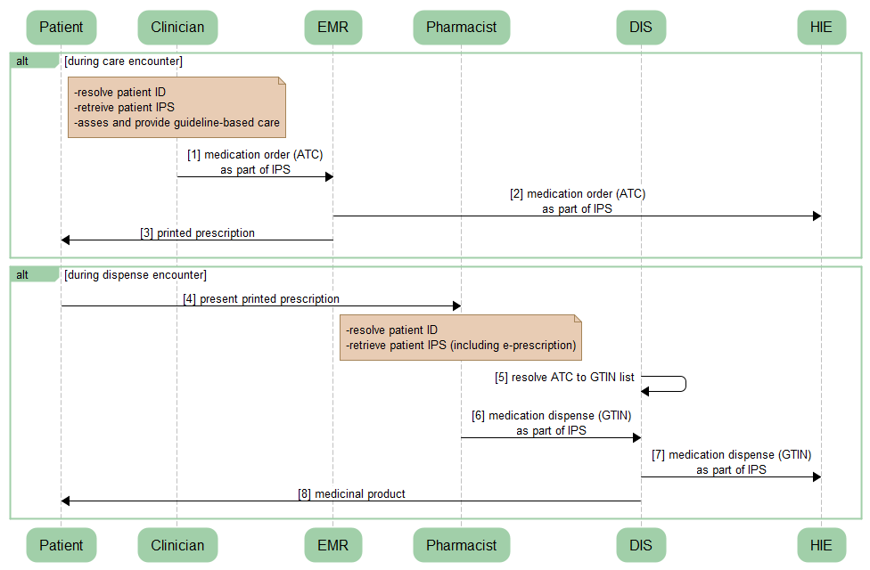
Figure 27 - Medication Order / Dispense Transactions
A generic mediation order / dispense workflow is illustrated in Figure 27. Following the transaction flow:
- During a care encounter, a clinician may order medications for a patient. The medication order is recorded in the EMR and communicated to the HIE as an update to the patient’s IPS-based health summary document (transactions [1] and [2]). A printed prescription is provided to the patient (transaction [3]). Importantly, the electronic medication order is coded using WHO’s Anatomical Therapeutic Chemical (ATC) classification code list. At the time of the order, the drug is indicated – but not its brand name or its packaging configuration.
- When a patient presents his or her prescription to a pharmacist (transaction [4]), the pharmacist uses a Drug Information System (DIS) to resolve the patient’s unique ID and retrieve the patient’s IPS-based health summary, including their electronic medication order, from the HIE.
- The DIS uses a mapped database to cross reference WHO ATC codes to GS1 Global Trade Item Number (GTIN) codes (transaction [5]). GTINs are globally assigned and managed codes used by all drug manufacturers; they are the identifiers barcoded on the packaging of medications.
- From the list of candidate medicinal products, the pharmacist chooses which to dispense to the patient based on the MOH’s formulary, on stock availability, and on the insurance coverage (and perhaps personal choice) of the patient (transactions [6], [7], and [8]).
The importance of the ATC-to-GTIN mapping database cannot be overstated. Prescription transactions are coded using drug codes (ATC); dispense transactions are coded using product (GTIN) codes. Computable care guidelines, and important patient safety routines such as drug-to-drug interaction algorithms, are expressed using ATC codes. For its part, the dispense transactions’ GTIN contains manufacturer and lot number information that is important for post-market surveillance (regarding reactions, for example) and is essential in supporting medication recall workflows, if necessary.
The GTIN-based transactions also provide essential information needed by the LMIS to support usage analytics that underpin stock replenishment and management decision-making. A similar mapping of clinical activities to supply chain consumption may be done for HIE transactions related to immunizations, lab tests, surgical procedures, etc. This same cross-domain pattern may be employed, beyond supply chain transactions, to support integrations to health insurance transaction processing and other key supporting workflows.

Point of Service application (POS)
[This section will need to be edited to reflect alternate approaches, where these are to be adopted.]
Point of service (POS) applications shall adhere to a pattern of processing that enables them to be “well behaved” digital health participants in the HIE. This pattern was illustrated in Figure 15 (replicated below, for ease of reference).
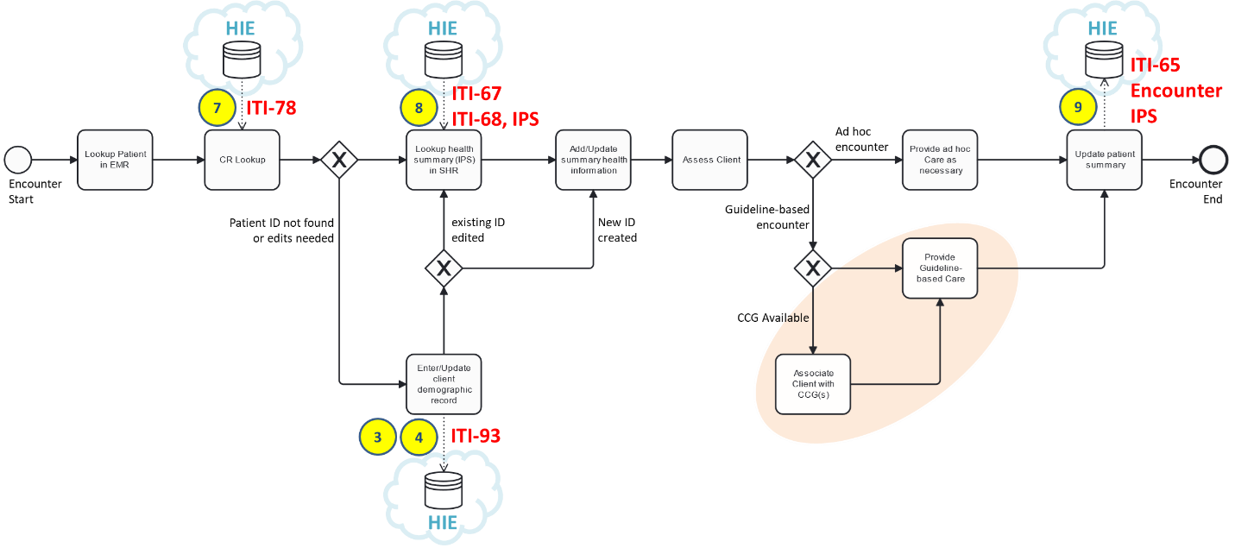
As predecessor steps prior to the beginning of the care encounter workflow (not shown in the figure), the application shall enable the health worker to login and to establish the context of care delivery. It is mandatory that digital health applications are secure and that they protect access to personal health information (PHI) by requiring authentication of health workers via, at a minimum, unique user login credentials. It is also mandatory that an application can cache the health worker ID and the location ID once the login is accomplished; these data are needed to support transaction processing with the HIE for every patient encounter.
Referencing the figure, the care encounter workflow steps may be described as follows:
- The patient is looked up in the local digital health application (e.g. the EMR).
- The same patient lookup is executed against the CR as an ITI-78 transaction.
- If the patient demographic content from the CR needs to be updated, or if the patient is not found and needs to be entered into the CR (and locally), the workflow progresses to the Enter/Update Patient data step. At this step, the updated or new patient data is persisted to the CR via an ITI-93 transaction. NOTE: the patient.id GUID will be assigned by the CR* POS solution actor and will be faithfully persisted by the CR. If a health card or other “wallet ID” cannot be issued at the time a new demographic record is being created, this GUID is also persisted as the MOH-assigned identifier (patient.identifier). If the POS solution is not playing the role of the CR* POS actor, then following this step in the encounter (which will accomplished using the CR* POS), the POS solution will return to step 2 of this process.
- If the patient update is completed, or if it was not needed in the first place, the patient’s health summary “id” is queried from the HIE using an ITI-67 transaction and retrieved from the HIE via an ITI-68 transaction, which returns an IPS document as the query response.
- The IPS content is reconciled with the local data and both are updated as appropriate. If no IPS was returned by the HIE, then the appropriate background and health history information is captured, in its entirety, during this workflow step.
- The patient is assessed to determine the presenting issues and to ascertain whether the encounter’s care pathway will be to provide ad hoc care or whether the patient’s encounter should follow a guideline-based care plan.
- If the encounter should follow a guideline-based care plan, and if a computable care guideline (CCG) is supported, then the appropriate CCG is leveraged. NOTE: this specification is silent on how the CCGs are made available to the POS solutions. There may be circumstances where the CCG is retrieved from the HIE via an ITI-68 transaction, which returns the CCG bundle – but it is not expected that these would be runtime transactions during the encounter.
- The patient receives either guideline-based care or ad hoc care, as appropriate. The care encounter context is logged, and the care activities are faithfully updated to the POS’ database. An encounter resource is created which is uniquely identified by a GUID, and which cross-references the provider ID, facility ID, client ID, and care encounter timestamp. This encounter resource plus a new IPS document (updated to contain the results of the present encounter) are together submitted to the HIE, in a single bundle, using the ITI-65 transaction.
For purposes of conformance to this spec, a POS shall be able to:
- Authenticate a health worker and establish both the health worker’s unique ID and the unique ID of the care facility. For authentication, the application may have to play the role of an IUA Authorization Client and execute ITI-71 (or implement some functionally equivalent authentication mechanism, such as public key infrastructure (PKI)). To fulfill these mandatory requirements, a POS solution may be required to play the role of a Care Services Selective Consumer and execute an ITI-90 transaction as defined by the mCSD profile. It is mandatory that the application will also need to be able to play the role of a CT Time Client and execute ITI-1 and play the role of an ATNA Secure Node/App and be able to execute transactions ITI-19 and ITI-20 as defined in the IHE ITI Technical Framework.
- Play the role Patient Demographics Consumer and execute transaction ITI-78 and as defined in the PMIR profile.
- If supporting the CR* POS role, play the role of a Patient Identity Source and execute transaction ITI-93 as defined in the PMIR profile.
- Play the role of an MHD Document Consumer and execute transactions ITI-67 and ITI-68 as defined in the MHD profile. A received PCC-IPS health summary document must be ingested, parsed, and persisted to the application’s local data store.
- Play the role of an MHD Document Source and execute transaction ITI-65 as defined in the MHD profile. The IPS health data content profile must be generated from the content in the local data store as normatively defined in the IPS profile. NOTE: it is essential that resource.id values are properly managed by the POS solution. Resource id’s contained in IPS documents returned by HIE queries must be faithfully persisted to the local data store and faithfully returned in any updated IPS document. For new IPS content reflective of the activities of the encounter, the POS solution must generate GUIDs for all relevant resource.id values.
- On a periodic basis, the POS solution may be required to play the role of a Content Creator and submit indicator reports to the HMIS via the QRPH-53 transaction as defined in the ADX profile. Such report schema will be defined by the MOH and POS solutions will be conformance-tested to confirm their ability to correctly generate reports adherent to these schemata.
For a dedicated CR* POS solution that is only used for onboarding new client demographic records, only requirements 1, 2 and 3 (listed above) must be met.

Digital Health Landscape and Quick-win Opportunities
Key points:
- Point One…
- Point Two…
- Point Three…
Key recommendations:
- Recommendation One
- Recommendation Two

[In this section, a listing should be made that reports the current digital health landscape, with particular focus on solutions that have been widely deploy and which may be able to be incorporated into the national HIE either at the cloud (shared infrastructure) side or the POS side.
Based on the functional footprint of the solution, it should be mapped to the actor or actors listed in the previous section. It is common for legacy, purpose-built solutions to play the role of multiple actors. A widely implemented EMR solution, for example, will contain client demographic data (CR) as well as person-centric health information (SHR). The solution may be anticipated to play one or both of these roles as part of the national digital health infrastructure initiative – or it may be simply that the extensive data stores in a solution will be leveraged to “seed” national registries, which will be separately deployed in the cloud.
As a practical matter – if there are legacy solutions that are to be incorporated as part of the national infrastructure, a façade approach has many advantages. An example of such an approach is illustrated by the graphic above. Where there is an existing health worker database solution and an existing facility registry solution, these may be incorporated into the HIE by adding ITI-91-conformant façades to each solution. Technically, each façade would map between the data models of the legacy solution and the data models of the conformant FHIR-based IHE Profile (in this example, the mCSD Profile). On a regular batch (run daily, perhaps), the map would be used to synchronize content from the legacy solution to the HIE’s FHIR Server.
Such an approach minimizes the software changes needed to operationalize a conformant HIE FHIR Service. At the same time, the MOH can continue to leverage existing data integrations and existing governance processes associated with the legacy solution.
This section need not be exhaustive; there does not need to be an inventory of every digital health solution used in the country. Rather – it should highlight large scale solutions that will either become part of the new infrastructure or will need to be modified (possibly leveraging a façade pattern) so that they can connect. Where there are key opportunities to accelerate the time to value, these should be identified, and the level of effort associated with leveraging legacy solutions should be estimated.]
This section lists key digital health solutions, their use cases, where they are deployed, who is supporting them, and germane technical attributes (where known). These are mapped to the architecture described in Figure 14 and implications and quick-win options are discussed.

High-level overview of broadly deployed digital health solutions
<Insert a list of broadly deploy solutions and discuss their present deployment status and germane technical information (such as data or interoperability standards supported by the solution).>

Mapping existing solutions to HIE actors
<Leveraging the nomenclature of Figure 14, define how applications (or subfunctions within applications) will map to the HIE infrastructure. Provide estimated level of effort to achieve integrations as well as top-level descriptions of strategies (e.g. façade approach, etc.) and their implications.>

Governing the National HIE
Key points:
- Point One…
- Point Two…
- Point Three…
Key recommendations:
- Recommendation One
- Recommendation Two

[This section describes important policy and governance elements necessary to support the HIE and the legal basis of its operations. The country context must be reflected in this section. Existing laws and government policies relevant to health data sharing should be cited. National privacy and consent norms may differ (possibly substantially) from those outlined below as example text.
Elements of the following example text and/or the graphics may be leveraged as archetypal language. It should be noted that these graphics and text have been leveraged in multiple countries to inform updates to existing legislative frameworks and to inform the establishment of new programme management offices (PMO) to support national HIE initiatives.]
This section describes policy options which could be leveraged ensure the necessary legal basis is in place for nation-wide sharing of person-centric, protected health data. A digital health governance framework is proposed which would coordinate efforts across all national projects and programmes.

A conceptual policy framework for national scale health data sharing
This section describes a policy structure that supports national scale health data exchange across both private and public sector care providers.
Two key digital health related policy recommendations are anticipated to be especially impactful and foundational in support of the national HIE:
- Health Data Governance Policy
- Health Data Sharing Policy

Health Data Governance
To support the large-scale implementation of digital health care delivery solutions, it is essential that the applicable rules of person-centric health data management and governance are defined and enforced for all parties, both in the public sector and the private sector. To provide a legal basis for a national HIE, regulations must define the parties over whom governance will be exercised. The three relevant parties are: health data owners; health data custodians; and health information network providers.
It is an international best practice that data about the care subject is owned by the care subject. Care provider organizations are health data custodians. The MOH, or related agencies or departments, become health data custodians when they maintain person-centric data holdings in shared health record (SHR) repositories or other related registries that form components of the national HIE. Parties that process health data, but do not retain it, are not custodians but are considered network providers.
Different regulations apply to health data owners, health data custodians, and health information network providers. Typically, as the owner of data about himself or herself, a subject of care should have a right to access their own data and may share their personal health data with whomever they choose. This right applies to digital data in the same way as it would apply to paper copies of personal health data. Health data custodians are generally required to safeguard data holdings, ensure they are available when they need to be, and ensure they are only used by authorized persons for authorized purposes. All healthcare providers are health data custodians. Network providers are typically required to ensure the integrity of the content they convey and to ensure that their operational processes do not inadvertently create data holdings that would cause them to become a custodian. These actors are depicted in Figure 29.
Figure 29 – Conceptual Health Data Governance Actors
[There are useful examples of Health Data Governance legislation that may be employed as models to consider in drafting its domestic legislation. As an example, from Canada, the Province of Ontario’s Personal Health Information Protection Act (PHIPA, 2004) outlines a model regulatory framework for health data owners, custodians, and network providers.]

Health Data Sharing
To operationalize the national HIE, Health Data Sharing legislation may be needed to provide a legal basis for its operation. There are two key aspects to be addressed by such a policy framework:
- Patient consent management; and
- Patient rights related to safety and quality of care.
As a best practice, patient consent regarding health data sharing should be based on an implied consent or opt-out model. In plain terms, this means a patient’s data will be shared within the care delivery network, for the purpose of delivering care to that patient, unless the patient explicitly decides they wish to withdraw their consent for such sharing. This option is preferred over explicit opt-in consent because of its fundamentally easier implementability and scalability. That said, it is important that citizens must have the right to withdraw their consent to share their data. This right is foundational to the notion of health data ownership referred to in the previous section.
As a useful example of what is the scale of consent withdrawals that can be expected, of the 5.1 million patients with records in the National Electronic Health Record (NEHR) system in Singapore, approximately 0.01% have opted out of data sharing. Even though these numbers are low – without the option to withdraw consent there is no actual right of privacy on the part of the citizenry. It is a must-have.
Typically, a patient can withdraw their consent to data sharing, but cannot withdraw their consent to have their data collected. This distinction is important. Patient-level health data collection is necessary to support key business processes. Care provider organizations need these data for managing provider payments processes, meeting medico-legal requirements, and satisfying regulations related to mandatory notifiable public health reporting. Usefully, such a collect-but-not-share policy approach means that content that was collected during the period when consent had been withdrawn can again be shared if the patient reconsiders their decision and later reinstates their consent for data sharing. The collect-always and share-by-default approach is illustrated in Figure 30.
Figure 30 – Conceptual Data Sharing Consent Model
As a matter of implementability, it is useful to adopt as a default policy that all health data will be shared with all care providers unless consent to do so has been revoked. Although it is theoretically possible to articulate fine-grained data sharing rules that can describe consents to share some content with some care providers and other content with other providers – the practicalities of such approaches are daunting.
For these reasons – as a starting point – a simple consent policy is recommended that affords the patient the right to choose to be either all-in or all-out. This all-in default behaviour is illustrated in Figure 30. The patient’s consent directive decision gate (black diamond) will share data across the care delivery network (data flows shown in green) unless the patient’s consent rule is explicitly set to NO.
There have been, in some jurisdictions, challenges in having private sector actors share patient data (which they may regard as customer data). To combat issues related to health data blocking or hoarding, health data sharing policy should be framed as a patient rights issue. The premise for such an approach is that each patient is entitled to safe, high-quality healthcare. The delivery of safe, high-quality care relies on good care continuity and this, in turn, relies on health data sharing across the care delivery network (including both public and private sector providers).
This premise is also illustrated in Figure 30 where it may be noted that data flows on a mandatory basis from Direct Care Providers to patients (as owners) and to the MOH (who, alongside the Direct Care Provider, is also a custodian). These MOH data holdings are operationalized by the secure data sharing infrastructure of the HIE. In situations where private sector players have been reticent to share health data about their patients, framing the data sharing as a patient rights issue establishes a legal basis for prohibiting data blocking or hoarding by care providers.
[There are examples of health data sharing legislation that may be leveraged to inform policy development. The College of Physicians and Surgeons of Ontario (Canada) has a Medical Records Management policy that includes stipulations about clinicians’ local electronic data storage. On a jurisdictional basis, a data exchange policy example may be taken from the Ontario Health Digital Health Playbook. As an example of anti-data-hoarding legislation, the US health data sharing policy CMS-9115-F, the Interoperability and Patient Access final rule, provides a good example. There is also a good example of policy analysis from the European Patients Forum regarding how recent EU legislation regarding health data sharing may be viewed from a patients’ benefits viewpoint.]

Exerting MOH governance over disparate digital health projects
To operationalize the national HIE, it will be important to coordinate and govern the activities of multiple stakeholders and their projects.
Figure 31 – Conceptual DH Governance Structure
Figure 31 illustrates a conceptual digital health governance structure informed by country examples that were generally adherent to the Paris Declaration. Such a governance structure may be leveraged to coordinate digital health activities. Its operation may be described, at a high level, as follows:
- The Government may benefit from grants and/or loans from Development Partners. Some funds may directly be targeted to health-related initiatives or to digital health, specifically; others may be more general.
- The Government empowers and funds the Ministry of Health (MOH) to execute activities within its national mandate. Successful execution of this mandate relies on digital health, which will receive project funding for new initiatives and sustaining funding for ongoing operations.
- MOH and its relevant departments and agencies will engage with Development Partners to coordinate activities and to ensure projects and programmes are aligned to MOH’s strategies, priorities, timelines, and the norms and standards documented in its digital health blueprint.
- MOH will empower and fund a Digital Health Department (or Agency) to be the body that exercises the specific mandate related to executing the national digital health strategy. This department will operate a Programme Management Office (PMO) that exerts governance over all digital health projects in the country. All Project Managers (PMs) will coordinate their efforts under the auspices of the PMO regardless of whether they are overseeing MOH-funded or Development Partner-funded projects.
- As an instrument of this governance, the Digital Health Department will conduct the conformance testing of implemented solutions to ensure they are adherent to the national norms and standards for digital health. All digital health solutions, whether implemented by public or private sector entities, will be subject to successful conformance testing before they can participate in the national HIE.
The Digital Health Department will also have a role in addressing digital health skills gap. Capacity-building, generally, will focus on requirements related to ongoing HIE operation. To address short-term requirements, external capacity will be leveraged to support one-time tasks related to implementation. All external contractors will operate under the governance of the PMO. Specific train-the-trainer capacity-building will be used to close gaps in frontline workers’ abilities to leverage digital health at the point of service, and to close gaps related to IT technical support within the care delivery network.
Specifically related to pandemic and epidemic preparedness and response, the Digital Health Department may explore opportunities to collaborate with Mobile Network Operators (MNOs) through the GSMA’s M4D initiative. Such collaboration may help address challenges related to big data analytic capacity shortfalls that can be important in addressing public health emergencies.
In summary, it is expected that the activities of the Digital Health Department will include:
- Operating the Programme Management Office that exerts governance over all digital health projects and programmes (including projects executed by the MOH and those of development partners).
- Operating the national digital health conformance-testing platform. This platform should include both a 24x7x365 sandbox that may be employed by innovators to experiment against a reference implementation plus an assessment test rig that could be employed to certify digital health solutions against the norms, standards and mandatory behaviours delineated in the Digital Health Blueprint.
- Providing a Center of Excellence in digital health that can provide thought leadership to inform decision makers and policy makers at MOH and in the Government as well as develop and disseminate educational materials to be leveraged by participants throughout the digital ecosystem (e.g. academia, private sector start-ups, and care delivery participants at all levels of the network).

Conclusion & Next Steps
[This section describes the process for leveraging the present document to inform MOH’s National Digital Health Blueprint. Sample text is included below. This sample text should be edited to appropriately reflect the country’s context and its plan for dissemination of the blueprint and its accompanying specifications.]
The target audience of the present document is the MOH. The role of this document is to inform the publication, by the MOH, of a set of national Digital Health Blueprint artefacts. These will be reference artefacts; they should be published in the country’s official language. The overall “Blueprint” should be released in two complementary parts, each part focused on a defined audience.

Developing the Blueprint Artefacts

National Digital Health Blueprint
This Blueprint document should target non-technical health system stakeholders who have an interest in the digital health agenda and will participate in the national implementation, whether actively or as supporters. This document should “make the case” for the national plan.
To establish context, it can summarize content from the Burden of Disease, Digital Health Readiness, and National Health and Digital Health Strategies sections. To indicate the MOH’s chosen technology-related direction, summary information and graphics from the Overview and background and Conformance-testable Building Blocks subsections of the Components of a “buildable” Health Information Exchange section can be leveraged. Technical details of the implementable specifications should not be included; rather the Blueprint document should refer to the companion document: the National Norms & Standards for Digital Health.
The concluding section of this Blueprint should describe the Ministry’s planned governance structure and note relevant legislative changes that will be enacted to support the project. Optionally, references can be made to the Investment Rationale and the budget, timeframe, and health impact (ROI) targets that it establishes.

National Norms and Standards for Digital Health
This technical specification should be targeted to health informatics professionals who will be involved in the design and deployment of conformant digital health infrastructure and point of service solutions. It need not replicate the contextual information included in the Blueprint, but rather should refer to it.
High level conclusions from the Blueprint’s context-setting chapter can be summarized in a short introduction. The Components of a “buildable” Health Information Exchange section can be leveraged, in its entirety, as the normative description of the national norms and standards. Where decisions have been made to incorporate existing legacy solutions (as described in the Digital Health Landscape and Quick-win Opportunities section), these should be described, and illustrative architecture diagrams should be included.
The concluding section of this Norms and Standards specification should describe the MOH’s planned approach for conformance-testing as well as any supportive (prototyping environments) that will be provided to assist technical teams in meeting the national requirements. Citations should be provided that reference relevant legislation regarding the normative requirements for digital health solutions.

Publication and Dissemination
The national Blueprint artefacts should be officially published and noted in the government’s Gazette. The National Norms and Standards for Digital Health should be officially adopted by enacting a Policy of the Ministry of Health that references this national specification and establishes an enforceable requirement that digital health solutions in the nation’s are ecosystem shall operationalize these specifications and shall connect to the national HIE within the specified timeframe.
The governance structure of the MOH should adopt ownership of both the Blueprint and the Norms and Standards. Both documents will be refreshed on a regular timeframe established by the Policy. Maintenance of the Norms and Standards will be taken on as an ongoing responsibility of the relevant Digital Health Department or Agency.
Optionally, press conferences and informational seminars may be hosted by MOH Leadership to build social awareness of the project and its implications for the population.

Appendix 1: Example Use Case – Diabetes
This section outlines an example workflow for guideline-adherent diabetes care. It includes the mandatory behaviours necessary for good HIE “citizenship”, such as establishing a unique client ID, obtaining a patient summary from a shared repository, providing guideline-based care during an encounter, and updating the shared health record repository with the encounter’s details. It will describe the NCD workflows in terms of the blueprint’s transactions and illustrate the conformance-tests that could be applied to a digital health solution to demonstrate that it is adherent to the blueprint. This set of scenarios could be used for demonstration purposes (e.g. at a conference or an AeHIN Convergence meeting) or for testing purposes at an official MOH “Projectathon” event.

Archetypal Transaction Patterns
This example use case is expressed using a simplified set of archetypal transaction patterns operating within a digital health architecture that includes the key actors identified in Figure 14. For these archetypal patterns, the relevant participants are:
- patient – the subject of the care encounter
- HW – the health worker that is the provider of care during the encounter
- app – the digital health solution used by the health worker
- IL – the interoperability layer actor that supports security, authentication, and transaction orchestration between the app and the other actors in the digital health shared infrastructure
- CR – the client registry actor that supports resolution of the patient’s unique ID
- ILR – the interlinked registry actor that supports resolution of unique facility, organization, health worker, and health service IDs and codes
- SHR – the shared health record repository that contains health summary documents based on the International Patient Summary (IPS) specification as well as encounter records and, if applicable, computable care guideline records (CCGs)
At a top level, the transaction pattern may be described as follows:
A HW logs into their app and their credentials are established, including their access rights to the HIE. An HIE transaction (TX-A) establishes their care context. An access token is obtained, the HW ID, facility ID and organization ID are resolved, and the app is ready to begin recording care encounters.
FOR EACH CARE ENCOUNTER…
The patient’s unique ID is established (TX-B)
The patient’s health summary is retrieved from the national HIE (TX-C)
Guideline-based care is provided, leveraging one or more CCGs (TX-D)
A record of the Encounter, including the updated health summary, is posted to the national HIE (TX-E)
At the end of the work session, the HW logs out of their app
This top-level transaction pattern is illustrated in Figure 32. The details of each transaction are described in the following subsections.
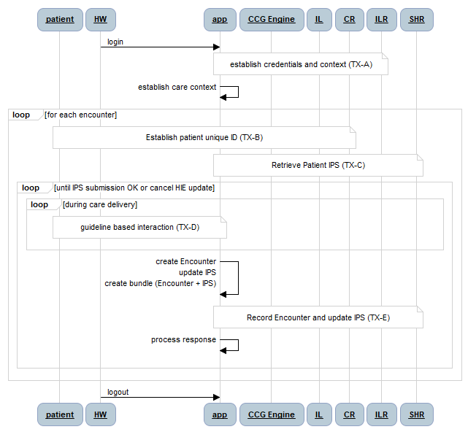
Figure 32 - Top-level Transaction Diagram
NOTE: it is assumed that all HIE transactions traverse the interoperability layer (IL) and that this enterprise service bus authenticates and authorizes HIE access. For brevity, it is not illustrated on the sequence diagrams that follow, but all HIE transaction will need to be coupled with an OAuth token (a companion ITI-72 transaction). As shown in the diagrams, all HIE transactions are audited using the IHE audit trail and node authentication, ATNA, transaction). Where necessary to meet the criteria outlined in the IHE MHDS specification, the IL will orchestrate transactions and enforce data consistency rules. These internal IL processes are not shown in the diagrams.

TX-A: Establish HW credentials and care context
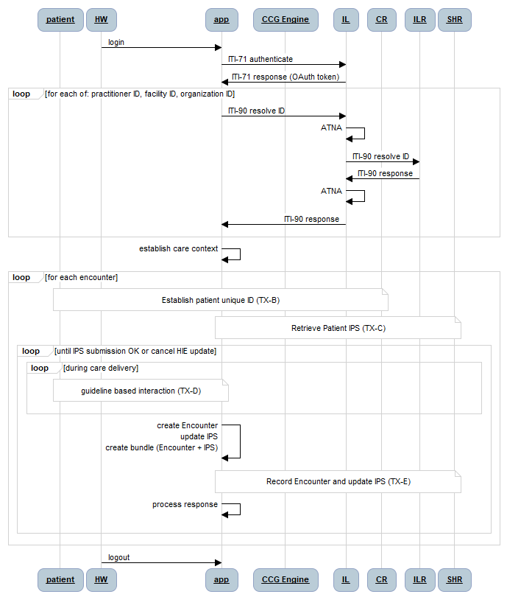
Figure 33 – TX-A: Establish Authorization and Care Context
The authentication, authorization, and care context transaction set (TX-A) is described in the sequence diagram in Figure 33. The health worker logs into his or her digital health solution (app) and the login credentials are leveraged to establish authorized access to the HIE and its shared data holdings. To enforce data governance and interoperability, the interlinked registry is used by the app to obtain and cache the unique national IDs that must be logged as reference data on each care encounter record (HW ID, facility ID and organization ID).

TX-B: Establish Unique Patient ID – TX-B
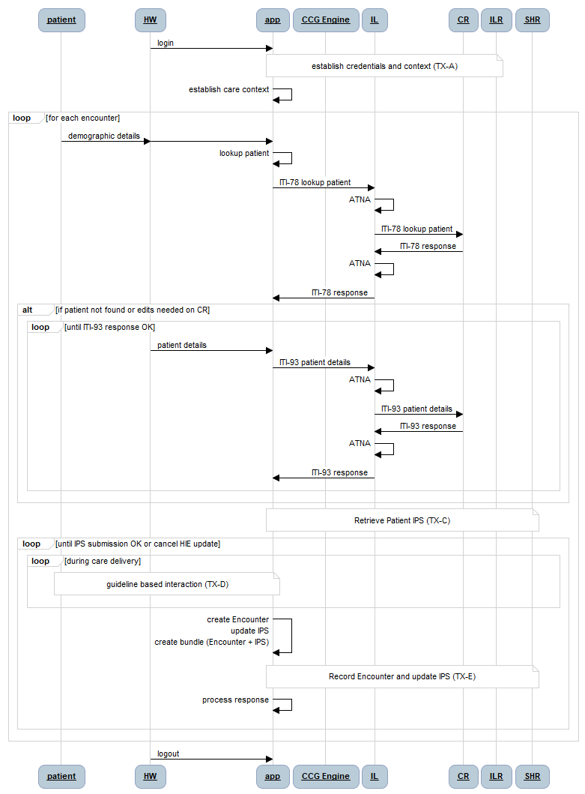
Figure 34 - TX-B: Establish Unique Patient ID
The patient ID resolution transaction (TX-B) is described by the sequence diagram in Figure 34. As illustrated by the diagram, patient demographic information is collected by the health worker (HW) and keyed into the app to execute a local lookup. The demographic information is then used to execute a lookup against the HIE’s client registry (CR). If the patient is not found, or if the local patient data is more up-to-date than the HIE’s demographic data, the app’s local demographic content is persisted to the CR.

TX-C: Retrieve Patient IPS
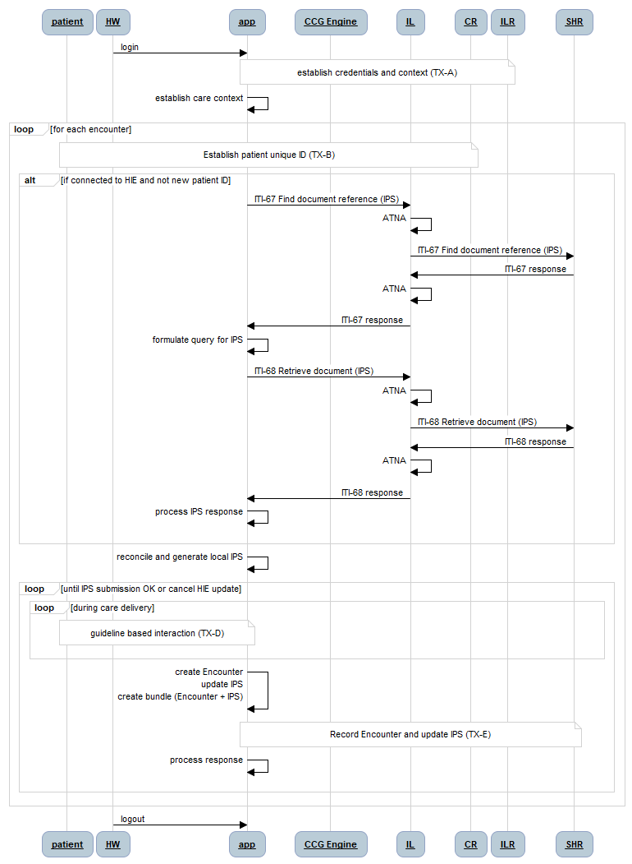
Figure 35 - TX-C: Retrieve Patient IPS
The patient health summary retrieval transaction (TX-C) is described by the sequence diagram in Figure 35. As illustrated by the diagram, following the successful execution of TX-B, a query is made against the app’s local database to retrieve the patient’s health summary. Using the patient’s unique ID, a query is made against the HIE’s shared health record (SHR) repository to find the patient’s most up-to-date International Patient Summary (IPS) document. The document ID for this IPS document is used to retrieve it from the SHR. This IPS is processed by the app, which reconciles it with the local health summary. If the IPS contains information not in the local summary, the local database is updated. If the app’s summary data is a superset of the IPS, then the local copy of the HIE’s IPS document is updated to reflect the more up-to-date content.

TX-D: Guideline-based care delivery
For the purposes of this demonstration, it is assumed that a computable care guideline (CCG) is developed that reflects national diabetes care guidelines. Notionally, a CCG can be metaphorically thought of as a “folder” full of “cards”. The guideline-based diabetes care recommendations would be contained in a Diabetes folder. Following the analogy, guideline-based antenatal care recommendations would be contained in an ANC folder. Depending on the diagnoses reflected in a patient’s health summary document (their IPS), one or more CCG folders may be applicable to them. Following the present example, a pregnant woman who is under care for diabetes would have both an ANC folder and a Diabetes folder associated with her IPS.
Each guideline-based recommendation for diabetes care can be thought of as being represented by a “card” in the Diabetes “folder”. Every card has three key elements (the C-A-R):
- A “Condition statement” that defines when this card is applicable;
- A care “Action” instruction that defines what is recommended when the card’s condition statement is evaluated to be TRUE; and
- An action “Result” that defines what will be documented in the patient’s IPS after the action is taken.
An example illustrates this metaphor. An example country’s Clinical Practice Guidelines for Type 2 Diabetes describes the first-line use of Metformin and second-line use of Sulfonylureas to reduce high glucose levels. Both medications are on the essential drugs list.
Figure 36 - The country’s Type 2 Diabetes Guideline re: Glucose Lowering Agents
A Diabetes folder would contain a card for every recommendation in the National guideline, including routine initial, follow-up and annual visits. An example card for Metformin (the C-A-R) can be narratively described as follows:
Metformin
- Conditions for applying the card (all must be TRUE):
  - HbA1C > 9% or fasting BSL > 180 or postprandial > 360
  - (Cr < 1.5mg/dL and Sex=Male) OR (Cr < 1.4mg/dL and Sex=Female)
  - Age < 80 years
  - Number diagnosis of heart failure = 0
  - Number diagnosis of hepatic disease = 0
  - Number current findings of high alcohol intake = 0
  - Number existing orders for Metformin = 0
  - The card has not already been “applied” during the present encounter
- Actions to recommend if all Conditions are TRUE:
  - Order Metformin 500mg 2 time daily with meals
- Result of the recommended action having been taken (one of the 2 options):
  - Medication order for Metformin (ATC code A10BA02) dose = 500mg, route = by mouth, timing = 2 times per day (with meals) for 4 weeks, status = active
  - Medication order for Metformin (ATC code A10BA02) dose = 500mg, route = by mouth, timing = 2 times per day (with meals) for 4 weeks, status = cancelled, reasonCode = {select code from list in Figure 37}
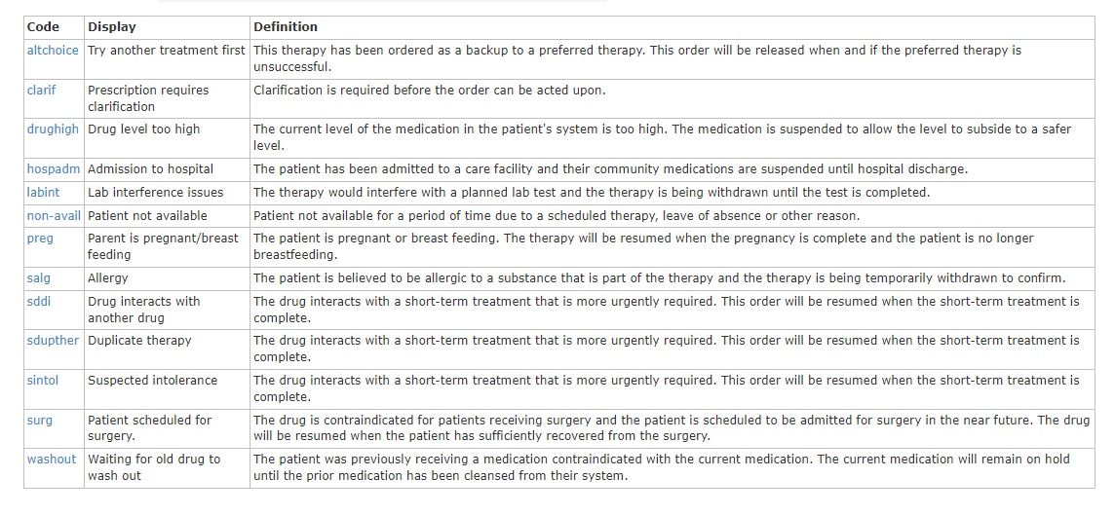
Figure 37 – Normative list of Medication Status Reason Codes
As may be noted from the Metformin example – the logic rules expressed by the C-A-R operationalize the The country care guideline. If the Conditions are met, a clinician will be presented with the recommended Action to begin Metformin for their patient. The Result written to the patient’s health summary document will either be an active prescription for Metformin, or a cancelled prescription for Metformin with a reason code indicating why the clinician has foregone the guideline-based recommendation. It should be noted that, if a clinician has foregone the Metformin option, the alternate Sulfonylureas option will be next proposed (defined by a separate card). For patients who are already on Metformin, there will be cards defined that would gradually increase their dosage levels, per the guidelines, until such point as the second line option should be tried (if blood glucose levels were not brought back to target levels).
There are card “types” defined for the tasks that occur during a care encounter. These include medication order cards (as illustrated by the previous example), stop medication cards, cards to record observations (e.g. height, weight, blood pressure, heartrate, etc.), cards to order lab tests (e.g. HbA1C, CBC, x-rays, etc.) or procedures (foot exam, eye exam, etc.), cards to schedule follow-up visits, and cards to augment or escalate care by creating a patient referral. There are also cards to record the actioning of any order (e.g. dispense medications, report lab test results, report procedure results, etc.).
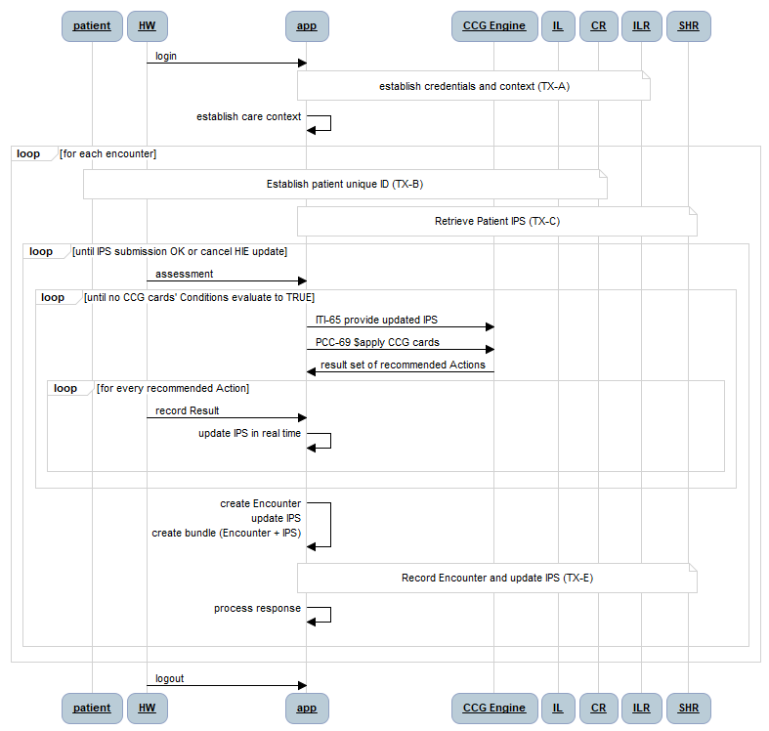
Figure 38 - TX-D: CCG Execution
The patient-safe card processing algorithm (shown in Figure 38) may be described as follows:
- The patient’s health summary is retrieved along with applicable CCG folders in TX-C; if a clinician so chooses, one or more new CCG folders may be associated to the patient during the assessment phase of the encounter
- Iteratively LOOP…
  - The updated patient summary (IPS) is submitted to the CCG engine
  - All the cards from all applicable folders are evaluated based on the current content in the health summary (invoked via a $apply operation submitted to the CCG engine)
  - For every card whose Conditions evaluated to TRUE
    - The clinician is shown the recommended Action
    - The clinician has either accepted the recommendation or indicated why it will be followed – and the appropriate Result has been written to the health summary
- …UNTIL no cards evaluate true

TX-E: Post Encounter details and updated Patient IPS to HIE
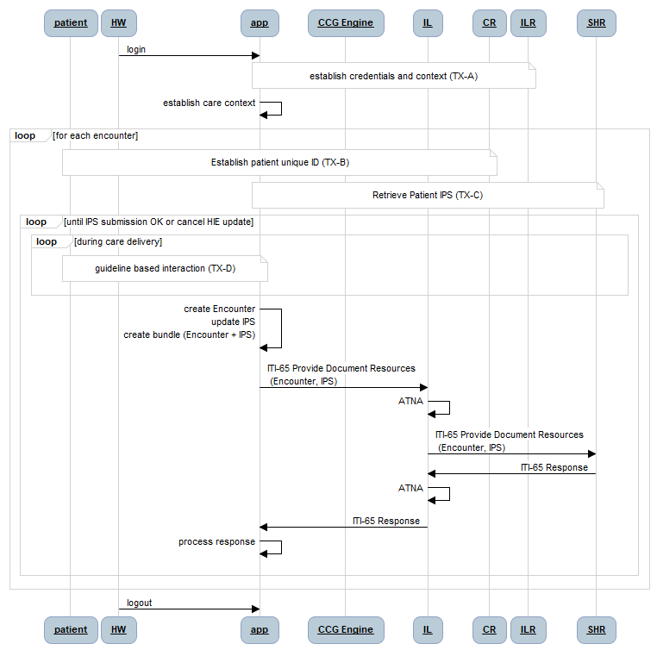
Figure 39 - TX-E: Post Encounter details and updated IPS to HIE
The patient encounter update transaction (TX-E) is illustrated by the sequence diagram in Figure 39. As illustrated by the diagram, following the successful execution of TX-B and TX-C, guideline-based care delivery activities are undertaken as per TX-D. The outcomes of these activities are reflected in an Encounter resource (which faithfully captures the context of the care encounter) plus an updated patient IPS document. The app creates a bundle including the Encounter and the updated patient IPS and persists this bundle to the SHR.

Demonstrating CCG-based Diabetes Care
A critical slice “demonstration” implementation of diabetes care, adherent to the country’s Clinical Practice Guidelines for Type 2 Diabetes, would require the architectural actors as described in the previous section. This means a simple HIE will need to be operationalized (perhaps leveraging a generic FHIR server plus a SanteMPI instance).
To successfully model the operationalization of CCG-based care workflows, including care escalation, at least two point of service EMR instances are needed. If at least a rudimentary CCG is created, including at least one care escalation “card” (e.g. referral to ophthalmologist), then the managed movement of a patient through the care network can be modeled.
To model care continuity, over time, and across multiple care sites, the following simple scenario may be leveraged:
- At a primary care facility, onboard a new diabetic patient not found in the CR. Leverage the history, examination, and blood tests outline for an Initial Visit. Execute TX-A to TX-E to establish baseline information about the patient, which is saved to the patient’s IPS on the HIE.
- Subsequently, at the same facility, execute a Follow-up Visit for the same patient. Execute TX-A to TX-E. Confirm details from step 1 are available in the patient’s IPS. Update the patient’s phone number. Record readings which establish that blood glucose levels warrant the first-line initiation of Metformin. Order and dispense the Metformin from the facility. Record encounter details in the IPS.
- Subsequently, at the same facility, execute an Annual Visit for the same patient. Confirm the details from visits 1 & 2 are available in the patient’s IPS. Execute TX-A to TX-E. Record results which establish that Metformin has successfully reduced blood glucose levels to within target. Establish a referral to an ophthalmic specialist for the annual eye examination.
- Subsequently, at the ophthalmic specialist’s facility, execute a Referral Visit. Confirm the patient’s IPS details reflect steps 1, 2 & 3. Execute the eye examination and record favourable results to the patient IPS.
- Subsequently, at the primary care facility, execute a Follow-up Visit. Confirm the results of the referral are found in the IPS. Execute TX-A to TX-E to record unremarkable results.
This simple scenario:
- Creates a new patient in the CR
- Finds, retrieves, and updates an existing patient’s CR record
- Creates a new patient IPS and saves it to the SHR
- Retrieves a patient’s most recent IPS from the SHR
- Saves an updated IPS to the SHR
- Triggers CCG-based recommendations based on data collected during an encounter
  - Orders and dispenses meds
  - Refers a patient to another care provider

Appendix 2: 10-year HIE Investment Rationale
[This appendix will reflect the results of using the HIE Investment Rationale spreadsheet tool to develop and 10-year cost-utility analysis (CUA) for implementing the country’s national HIE. The following section develops an illustrative report of using this tool with country content from Sierra Leone (SL) leveraged as the target country. This is not a work product of the Government of Sierra Leone – it is an illustration only, leveraging example data for that country.]
This section will describe the assumptions behind a 10-year investment rationale model and report the results of leveraging these assumptions in a digital health investment rationale spreadsheet tool evolved from the one used at the 2017 AeHIN General Meeting in Myanmar.

Assumptions

Demographics
As reported in the IHME metrics, the population of Sierra Leone (SL) is estimated to be 8.5 million with an anticipated growth rate over the coming 10 years of 2.6% (to a total of 11 million). It is assumed there are 16 districts and 190 operating units (one per chiefdom).
Figure - Health Human Resources (WHO, 2023)
It will be assumed, for purposes of the model, that the total population of health workers is 24,000 and that this population will grow at the same rate as the population growth rate.

Facilities
Figure - Facilities as per WHO Assessment (2015),
It is assumed that digital health will be deployed at all facilities in the SL care delivery network. To drive the costing model, three different cost categories are assumed:
- Large-scale digital health implementations with a one-time cost of $50,000 and digital system operating costs of $1000 per month (e.g. implement a cloud hosted solution; provide hardware and training for dozens of digital solution users; sustain hardware maintenance, network access, and local help desk support). For the model, it is assumed National, provincial, and referral hospitals are in this cost category. (est. 60 facilities)
- Medium-scale implementations with a one-time cost of $10,000 and operating costs of $100 per month (e.g. implement a cloud hosted solution; provide hardware and training for ~10 users; sustain hardware maintenance, network access, and remote help desk support). (est. 190 facilities)
- Small-scale implementations with a one-time cost of $5000 and monthly operating costs of $100 (e.g. implement a cloud hosted solution; provide hardware and training for ~5 users; sustain hardware maintenance, network access, and remote help desk support). Health centres are assumed to be in this category. (est. 1000 facilities)

Economics
Based on historical trends, an annual inflation rate of 15% was assumed. This rate drives the year over year cost escalation over the course of the 10-year model horizon.
As reported in the IHME metrics, the per capita total health expenditure (THE) for SL in 2019 was $45 (2019).
According to World Bank, SL’s GDP per capita was $480 (2021).

Theoretical DALYs
Values from IHME were used to develop the potential DALYs averted by the target interventions of this model: https://vizhub.healthdata.org/gbd-results?params=gbd-api-2019-permalink/d4464bfd84a2dd357ca4f181b6994fe2
Table - DALYs by Cause (IHME, 2019)
The disability-adjusted life-years (DALYs) associated with significant causes of death and disability are shown in Table 1. On a theoretical basis, it can be proposed that if 100% of the burden of disease could be alleviated by the application of digital health solutions for Malaria (#1 in the list), then 825 thousand “life-years” of lost health could be averted.
It is not possible to drive the disease burden to zero using digital health. Even so – sensitivity analysis can be leveraged to answer the question: “how much reduction in disease burden is reasonable to expect from the implementation of digital health – and what are the health impacts, expressed in economic terms, of such a reduction?”
Evaluating the economic value of health impacts is controversial. The long-standing rule of thumb from WHO is that an averted DALY that costs less than 3 annual GDP per capita is a “good buy” and an averted DALY that costs less than 1 annual GDP per capita is a “great buy”. Although this is a much-debated topic – the 1-GDP-per-capita-per-DALY is a simple and widely used heuristic and therefore is leveraged in this model.

Investment Rationale Model (example)
This section describes the values entered into the investment rationale model to develop a first-draft 10-year projection. These values are starting point examples. The relevant fields for each worksheet tab in the spreadsheet are noted in the following sections. NOTE: in the model – the green fields are filled in… all others are calculated.

Summary
The fields data-entered in the Summary tab are shown below.
Year-over-year cost escalation (%) | 15.0%
Annual facility growth rate | 1.0%
# Regions | 16
# Districts | 190
Population size | 8,500,000
Annual population growth rate | 2.6%
ID penetration rate (%/yr) | 33%
# Health Workers | 24,000
HW population growth rate | 2.6%

 | TYPE 1 | TYPE 2 | TYPE 3
 | 4.8% | 15.2% | 80.0%
1,250 | 60 | 190 | 1,000

These numbers reflect the assumptions listed in the previous section. The ID penetration rate of 33% per year indicates an expectation that, over a 3 year period, every SL resident will be issued a health ID card.

Governance
The fields data-entered in the Governance tab are shown below.
 | # | Units | Cost per Unit | Extended Cost
Digital Health Strategy
External advisors | 40 | days | $ 1,000 | $ 40,000
Workshops | 1 | each | $ 10,000 | $ 10,000
Regional meetings | 4 | each | $ 10,000 | $ 40,000
Subtotal |  |  |  | $ 90,000
Digital Health Blueprint
External advisors | 40 | days | $ 1,000 | $ 40,000
Workshops | 2 | each | $ 10,000 | $ 20,000
Regional meetings | 0 | each | $ 10,000 | $ -
Subtotal |  |  |  | $ 60,000
eHealth Norms and Standards
External advisors | 20 | days | $ 1,000 | $ 20,000
Workshops | 1 | each | $ 10,000 | $ 10,000
Regional meetings | 4 | each | $ 10,000 | $ 40,000
Subtotal |  |  |  | $ 70,000
Health Data Sharing Policy
External advisors | 10 | days | $ 1,000 | $ 10,000
Workshops | 1 | each | $ 10,000 | $ 10,000
Regional meetings | 4 | each | $ 10,000 | $ 40,000
Subtotal |  |  |  | $ 60,000
Digital Health Governance |  |  | Annual cost/unit | Annual costs
Committees | 1 | department | $ 100,000 | $ 100,000
Regular meetings | 50 | meetings | $ 100 | $ 5,000
National meetings | 4 | meetings | $ 15,000 | $ 60,000
Subtotal |  |  |  | $ 165,000

The assumptions regarding the strategy, blueprint, standards, and policy activities is that there is a consensus-building effort that may require outside TA. It is further assumed that these artefacts will be refreshed in year 5 and again in year 10 of the 10-year plan (and that the costs will be appropriately adjusted for inflation in these future years).
The last cost category, Governance, is assumed to be ongoing through every year of the 10-year plan with appropriate accommodation for inflation. This is the sustaining cost for operating a secretariat within a Digital Health Department plus the costs of the PMO and conformance testing services that this group will be responsible for.

Datacentre
These costs reflect the setup and operation of the national HIE. The costs are broken down as 1-time fees (license fees, installation fees, and virtual machine fees, where those might be applicable). Separately, the monthly operating costs are determined. These will be driven by prorated software maintenance fees and by VM costs and IT team size.
IT installer rate ($/hr) | $ 75.00
IT operator rate ($/hr) | $ 10.00
Software maintenance fee (% of license fee) | 15%

It is industry practice to pay an annual maintenance fee (often 15% of the original license fee) for enterprise class software. This supports the costs of upgrades and bug fixes and tech support. Even though there are many open-source options that SL should consider – it should not expect to be a “free rider” on these open source communities even where the license fee is zero. For this reason, a notional license fee was assumed for each software element, and this was used to drive “maintenance fees” that would be expected to sustain the ongoing costs of either commercial or open source products.
 | Software fee ($) | VM fee ($) | IT Effort (hrs) | Extended cost ($)
Datacentre Installation (1-time costs)
Client Registry (CR) | $ 100,000 |  |  | $ 100,000
Health Worker Registry (ILR-HWR) | $ 100,000 |  |  | $ 100,000
Facility Registry (ILR-FR) | $ 100,000 |  |  | $ 100,000
Terminology Server (TS) | $ 100,000 |  |  | $ 100,000
Shared Health Record Repository (SHR) | $ 100,000 |  |  | $ 100,000
Health Management Information System (HMIS) | $ 100,000 |  |  | $ 100,000
Interoperability Layer (IL) | $ 100,000 |  |  | $ 100,000
 | $ 700,000 | $ - | - | $ 700,000

A team of 7 FTE was assumed as the datacentre operations crew. These are notionally spread across the 7 software elements as 1 FTE per product… but that is only to easily use the model to develop the team size, not because it is expected to be 1:1. NOTE: the table below illustrates a MONTHLY operating cost estimate.
 | Software fee ($) | VM fee ($) | IT Effort (hrs) | Extended cost ($)
Datacentre Operation (monthly costs)
Client Registry (CR) | $ 1,250 | $ 100 | 160 | $ 2,950
Health Worker Registry (ILR-HWR) | $ 1,250 | $ 100 | 160 | $ 2,950
Facility Registry (ILR-FR) | $ 1,250 | $ 100 | 160 | $ 2,950
Terminology Server (TS) | $ 1,250 | $ 100 | 160 | $ 2,950
Shared Health Record Repository (SHR) | $ 1,250 | $ 100 | 160 | $ 2,950
Health Management Information System (HMIS) | $ 1,250 | $ 100 | 160 | $ 2,950
Interoperability Layer (IL) | $ 1,250 | $ 100 | 160 | $ 2,950
 | $ 8,750 | $ 700 | 1,120 | $ 20,650

CR (client registry)
For this tab, simple assumptions were made related to the cost per ID card (e.g. a simple paper or cardboard card that can be printed at a facility in real time). It was also assumed that these would have a 5-year validity period and that 1% of cards will need to be reprinted each year because they are lost or damaged. Every chiefdom and hospital health facility is assumed to be able to issue cards (facilities of type I and II). The setup cost for each facility (e.g. card printer) is expected to be $200 and a $50 monthly budget is set for consumables and maintenance.
ID provisioning cost ($/ea) | $ 0.05
ID renewal period (yrs) | 5
ID churn rate (%/yr) | 1.00%
ID issuing facilities (#) | 250
ID establishment setup cost ($) | $ 200
ID establishment operating cost ($/mo.) | $ 50

ILR-FR (Interlinked Facility Registry)
The costs for the ILR-FR are driven by the number of underlying data sources, the cost to connect each data source to the ILR (and to maintain this interface) and by the number of interactions the MoHS will need to have with each facility, each year in order to ensure the data is kept current and correct. The cost per interaction will vary depending on whether it is an in-person visit or a phone call. An average cost of $5 per “check” is assumed.
Facility databases (#) | 2
Cost per database application interface ($) | $ 10,000
API maintenance cost per year (%) | 15%
MoHS interactions per facility per year (#) | 1
Cost per interaction ($) | $ 5.00

ILR-HWR (Interlinked Health Worker Registry)
The cost drivers for the ILR-HWR are identical to the ones for the ILR-FR, with the exception that MoHS interactions to ensure data correctness involve data checks with health workers vs with facility operators. The idea is that a text message or automated phone message solution could be employed to confirm details with each health worker at least once per month. The estimated cost reflects connecting 4 underlying databases (e.g. from Colleges or Professional Associations, MoHS HR systems, etc.) plus the use of simple SMS message exchanges.
Health Worker Cadre databases (#) | 4
Cost per database application interface ($) | $ 10,000
API maintenance cost per year (%) | 15%
MoHS interactions per HW per year (#) | 12
Cost per interaction ($) | $ 0.20

SHR (Shared Health Record repository)
The cost drivers for the SHR are not as much related to the central server as they are related to the point of service (POS) applications that must be implemented at facilities and connected to the HIE. Here, the assumptions (denoted in the previous section) for implementation costs for each of the 3 different facility types drive the model. Also, it is assumed that each different POS application will need to be interfaced to the SHR and the costs of these interfaces will need to be maintained.
Unique health ICT applications (#) | 10
Cost per application interface ($) | $ 25,000
API maintenance cost per year (%) | 15%

For the deployments to facilities, an estimate is made of the implementation cost plus the annual operating costs. To model the timing, an estimate is made of the number of facilities that already have solutions implemented, plus the adoption rate per year (e.g. 33% per year assumes all will be implemented in a 3 year period). There is an expected requirement that MoHS interact with each facility to audit conformance or to refresh software or other tasks – and these costs are estimated by annual number of interactions and cost per interaction.
To be conservative, it is assumed zero facilities are HIE-ready, today.
Facilities (from Summary sheet) (#) | 1,250 | TYPE 1 | TYPE 2 | TYPE 3
Facilities of this TYPE (%) |  | 4.8% | 15.2% | 80.0%
Facilities of this TYPE (#) |  | 60 | 190 | 1,000
1-time ICT implementation cost for TYPE ($) |  | $ 50,000 | $ 10,000 | $ 5,000
Annual ICT operating cost for TYPE ($) |  | $ 12,000 | $ 1,200 | $ 1,200
Current ICT adoption by this TYPE (%) |  | 0% | 0% | 0%
Current ICT-capable by this TYPE (#) |  | - | - | -
ICT adoption increase per year (%) |  | 33% | 33% | 33%
MOH interactions per year (#) |  | 1 | 1 | 1
MOH cost per interaction ($) |  | $ 200 | $ 100 | $ 50

TS (Terminology Service)
The costs for the terminology service are driven by the number of underlying code lists that have to be licensed plus the annual maintenance fees per year for these licenses. For SL, it is expected that open standards will be leveraged so these costs are omitted. The other cost driver is the number of times the code lists must be refreshed by the POS applications and the cost of each refresh.
Total cost of codelist databases ($) | $ -
Codelist maintenance cost per year (%) | 15%
MoHS interactions per app per year (#) | 4
Cost per interaction ($) | $ 1,000.00

HMIS (Health Management Information System)
The HMIS costs are driven by the number of data warehouses, the cost for an SHR-HMIS data interface, and the annual maintenance costs for each interface. Operational costs are also driven by the number of data collections per year and by the cost of each of these data reporting workflows.
HMIS databases (#) | 2
Cost per SHR-HMIS interface ($) | $ 10,000
API maintenance cost per year (%) | 15%
HMIS data collections per facility per year (#) | 12
Cost per interaction ($) | $ 1.00

CUA (Cost Utility Analysis)
The CUA is a cost-effectiveness analysis. For this reason, the calculated 10-year costs based on the preceding assumptions are compared against the 10-year health benefits that can be expected to accrue from broadly deploying digital health in support of guideline-based care and care continuity.
Target cost/QALY (CET) | $480

As described in the previous section, a cost-effectiveness threshold (CET) is determined to be 1 annual GDP per capita (a “great buy”, based on the simple WHO heuristic). Also leveraging the section on Theoretical DALYs, the following 4 targeted diseases are identified as those amenable to being impacted by improvements in guideline adherence and care continuity.
For each target, the total health impact is identified, expressed as QALYs (which for this analysis are assumed to be equal to averted DALYs). The time to benefit, in years, is indicated for each. This is noting that benefits may not be realized until, for example, all of the health facilities have completed their digital health implementations. To support sensitivity analysis, a benefit realization value (expressed as a percent) is used to calculate how much of the total disease burden can be ameliorated through the digital health intervention. It is an underlying assumption that the impact of digital health will be to operationalize guideline-based care – and in this way, the health impacts could be dramatic. Even so, conservative benefit values of 1%, 2% and 5% were used to determine the cost effectiveness curves over the 10-year model horizon. NOTE: based on the assumptions listed in the previous sections, the CUA is not positive (e.g. is less than the CET) at less than a 2% benefits realization.

Results
Based on the assumptions in the model, the following results may be reported.
Figure - Cost-effectiveness over 10-year Horizon (2% health benefits Impact)
Assuming digital health interventions making a 2% impact on addressing 4 disease burdens (Malaria, Diarrheal Diseases, HIV/AIDS and TB), with a 3-year term before realizing benefits, it is modeled that a national-scale digital health investment across all facilities would achieve cost-effectiveness after 6 years. The 10-year investment model is shown in Figure 3.

Figure - 10-year Investment Model (Summary)
Figure - 10-year Benefits Model (2% benefits realization)

Discussion
The investment rationale spreadsheet tool is expected to be leveraged to support top-level planning. It may be leveraged to develop and evaluate scenarios and their impacts. The model results reported here are sensitive to the underlying assumptions, including a key assumption that digital health will impact health outcomes by improving adherence to care guidelines and care continuity and, hence, care quality.
The following may be noted from this model analysis:
- Over a 10-year model period, the assumed investment and operating plan would require an average annual digital health budget of approximately $6 million (escalating with inflation over the 10-year horizon to $12.6 million). Such an annual budget represents approximately 1% of total health expenditure.
- The model conservatively assumes that digital health investments are “starting from zero”. Where this is not the case, the time to realize benefits may be accelerated.
- A platform approach is recommended that could be employed to operationalize guideline-based care for any disease. This is in contrast with siloed investment in treating particular diseases or in providing services only for particular groups of patients.
- Using the burden of disease across only 4 conditions, and assuming guideline-based care operationalized through digital health would have an only 2% impact on this burden, and further assuming a 3-year implementation period during which zero benefits will accrue, the modeled investment plan is cost-effective by year 6. This scenario assumes all the cumulative costs, from inception, are “recovered” by the health benefits realization by year 6.

https://www.healthdata.org
https://ghdx.healthdata.org/countries
https://monitor.digitalhealthmonitor.org/map
https://apps.who.int/iris/handle/10665/75211
https://guides.ohie.org/arch-spec/architecture-specification/overview-of-the-architecture
https://wiki.ihe.net/index.php/Mobile_Health_Document_Sharing_(MHDS)
http://hl7.org/fhir/uv/ips/
Mandatory data (R) must be included in the IPS document. Required “if known” (S) data may be blank, but if it is available, it must be included in the IPS document.
https://www.snomed.org/international-patient-summary-terminology
https://www.whocc.no/atc_ddd_index/
https://loinc.org/
https://www.snomed.org/international-patient-summary-terminology
https://www.whocc.no/atc_ddd_index/
https://loinc.org/
https://profiles.ihe.net/ITI/SVCM/index.html
https://www.who.int/data/data-collection-tools/harmonized-health-facility-assessment/introduction
https://profiles.ihe.net/ITI/PMIR/index.html
http://build.fhir.org/ig/HL7/fhir-ips/StructureDefinition-Patient-uv-ips.html
https://profiles.ihe.net/ITI/MHDS/volume-1.html#1501-mhds-actors-transactions-and-content-modules
An example could be the HAPI FHIR server: https://hapifhir.io/
https://profiles.ihe.net/ITI/mCSD/
https://www.who.int/publications/i/item/harmonized-health-facility-assessment-(hhfa)
https://profiles.ihe.net/ITI/mCSD/index.html
https://www.ihris.org/
https://cdn.who.int/media/docs/default-source/health-workforce/dek/classifying-health-workers.pdf?sfvrsn=7b7a472d_3&download=true
https://build.fhir.org/ig/HL7/fhir-ips/OperationDefinition-summary.html
https://ips.health/
https://gdhp.health/
The IHE MHDS profile describes the overall operations of the HIE, including the support for health document exchange. The SHR’s behaviours are described within this overall context, here: https://wiki.ihe.net/index.php/Mobile_Health_Document_Sharing_(MHDS)
https://infoscribe.infoway-inforoute.ca/display/PCI/CA%3AFeX+Release+Information
https://simplifier.net/guide/CA-FeX/Home?version=current
https://profiles.ihe.net/ITI/MHDS/
https://www.dhis2.org/
https://ihe.net/uploadedFiles/Documents/QRPH/IHE_QRPH_Suppl_ADX.pdf
https://gazelle.ihe.net/category/default/ihe
https://profiles.ihe.net/ITI/mCSD/index.html
Ad hoc care is care that is not following a pre-defined guideline. This may be emergency care; however, this is not true in all cases that emergency care is ad hoc. Sometimes, emergency care may also be guideline-driven (head trauma, for example).
It is not expected, necessarily, that all POS solutions will be employed to onboard new client demographic records to the national CR. This may be a centralized administrative process that includes generating a unique ID card, for example. Or there may be a dedicated CR* POS app that all care sites are required to use, external to the digital health solution.
https://www.ontario.ca/laws/statute/04p03
https://www.ihis.com.sg/nehr/faqs
https://www.researchgate.net/publication/332530889_Digital_Health_Data_and_Information_Sharing_A_New_Frontier_for_Health_Care_Competition
https://www.cpso.on.ca/Physicians/Policies-Guidance/Policies/Medical-Records-Management
https://health.gov.on.ca/en/pro/programs/connectedcare/oht/docs/dig_health_playbook_en.pdf
https://www.cms.gov/newsroom/fact-sheets/interoperability-and-patient-access-fact-sheet
https://www.eu-patient.eu/globalassets/policy/data-protection/data-protection-guide-for-patients-organisations.pdf
https://www.oecd.org/dac/effectiveness/45827300.pdf
https://www.gsma.com/mobilefordevelopment/resources/webinar-on-demand-digital-health-a-tool-for-building-resilient-health-systems-in-a-covid-19-world/
https://en.wikipedia.org/wiki/Districts_of_Sierra_Leone
https://www.afro.who.int/sites/default/files/2023-06/WHO%20Sierra%20Leone%20Country%20Cooperation%20Strategy%202022-2025.pdf
https://www.afro.who.int/sites/default/files/2023-06/WHO%20Sierra%20Leone%20Country%20Cooperation%20Strategy%202022-2025.pdf
https://en.wikipedia.org/wiki/Healthcare_in_Sierra_Leone
https://data.worldbank.org/country/sierra-leone

